**JS TOPICS**

Here is the revised content without timestamps:

**Chapter 1: Data Types**  
1.1 Adding JavaScript  
1.2 Variables  
1.3 Data Types  
1.4 Strings  
1.5 String Methods  
1.6 Numbers  
1.7 Loose Equality vs. Strict Equality  
1.8 Type Conversion  
1.9 Arrays  
1.10 Boolean Values and Comparison Operators

**Chapter 2: Control Flow**  
2.1 For Loop  
2.2 While Loop  
2.3 Do While Loop  
2.4 if / else if / else  
2.5 Nested if Statement  
2.6 Break and Continue  
2.7 Logical Operators  
2.8 Variable and Block Scope  
2.9 Ternary Operator  
2.10 Switch Statement

**Chapter 3: Functions**  
3.1 Function and Function Expression  
3.2 Function Parameters and Arguments  
3.3 Return Statement  
3.4 Arrow Function  
3.5 Higher Order Function - Callbacks  
3.6 Higher Order Function - Returning Functions  
3.7 IIFE  
3.8 setTimeout and setInterval  
3.9 Hoisting

**Chapter 4: Objects**  
4.1 Object Introduction  
4.2 Function vs. Methods  
4.3 "this" Keyword  
4.4 for-Each Method  
4.5 Objects Inside Array  
4.6 Math Object  
4.7 Call, Apply, and Bind  
4.8 Pass by Value and Pass by Reference  
4.9 for-in Loop

**Chapter 5: DOM**  
5.1 DOM Introduction  
5.2 Query Selector  
5.3 Other Ways to Access Elements  
 **Chapter 6: DOM - Forms**  
6.1 Submit Event  
6.2 Regular Expression  
 **Chapter 7: Array Methods**  
7.0 Array Methods  
7.1 Slice  
7.2 Splice  
7.3 At  
7.4 Map  
7.5 Filter  
**Chapter 8: Date**  
8.1 Date and Time

**Chapter 9: LocalStorage**  
9.1 Local Storage Introduction

**Chapter 10: OOP**  
10.1 Constructor and new Operator  
10.2 Prototypes  
10.3 Prototypical Inheritance  
10.5 Setters and Getters  
10.6 Static Methods  
10.7 Class Inheritance

**Chapter 11: Async JavaScript**  
  
11.4 Callback Function  
11.12 Async/Await without Return Statement  
11.13 Error Handling Using Try-Catch

**Chapter 12: ES6**  
12.1 Array De-structuring  
12.7 for-of Loop

**Chapter 13: Modern Tooling**  
13.1 Importing and Exporting ES6 Modules  
13.4 Introduction to NPM

**Chapter 14: Advanced Concepts**  
14.1 Closures

14.1 BOOTStrap

**Introduction to JavaScript**

JavaScript (JS) is a high-level, dynamic, and versatile programming language primarily used for creating interactive and dynamic content on websites. It's a core technology of the World Wide Web, alongside HTML and CSS. JavaScript enables features like animations, form validations, interactive maps, and more.

**History of JavaScript**

* **Inventor**: Brendan Eich, a programmer at Netscape, created JavaScript in just 10 days in 1995.
* **Original Name**: JavaScript was initially called **Mocha**, then **LiveScript**, before being renamed JavaScript.
* **Relation to Java**: The name "JavaScript" was chosen as a marketing strategy due to Java's popularity at the time, but the two languages are entirely different.
* **Standardization**: In 1997, JavaScript was standardized under the name **ECMAScript (ES)** by ECMA International.

Key milestones:

* **1995**: JavaScript introduced in Netscape Navigator.
* **1997**: ECMAScript 1 released.
* **2015**: ECMAScript 6 (ES6) introduced modern features like let, const, arrow functions, and more.

**Developer of JavaScript**

* Brendan Eich, working at **Netscape Communications**, developed JavaScript to enhance web interactivity.
* Today, JavaScript is maintained by various organizations, including **TC39**, a committee under ECMA International.

**JavaScript Keywords**

Keywords are reserved words in JavaScript that have predefined meanings and cannot be used as variable names.  
  
  
Examples:

* **Control flow keywords**: if, else, switch, case, default, break, continue.
* **Variable declarations**: var, let, const.
* **Functions and loops**: function, return, for, while, do.
* **Special purpose**: this, null, undefined, new, delete, typeof, instanceof.

**File Name for JavaScript**

* JavaScript files have the extension **.js** (e.g., script.js).
* These files can be linked to an HTML file using the <script> tag:

<script src="**script.js**"></script>

**Literal in JavaScript**

Literals are fixed values directly used in the code.  
Examples of different types of literals:

* **Numeric**: 10, 3.14.
* **String**: "Hello", 'World'.
* **Boolean**: true, false.
* **Object Literal**:

**const person = { name: "John", age: 30 };**

**Constant in JavaScript**

* Declared using the const keyword.
* The value of a constant cannot be reassigned after its initial definition.
* Syntax:--🡪

const PI = 3.14;

console.log(PI); // Outputs: 3.14

* **Features**:
  + Must be initialized during declaration.
  + Useful for values that should not change, like configuration settings or fixed mathematical values.

**Chapter 1: Data Types**

### 1.1 Adding JavaScript

**Theory**: JavaScript can be added to HTML documents in three primary ways:

1. **Inline JavaScript**: Directly within HTML elements using the ((*onclick))*, (*onload)*, and other event attributes.
2. **Internal JavaScript**: Within the <script> tag inside the HTML document.
3. **External JavaScript**: In separate .js files linked to the HTML document using the <script src="script.js"></script> tag.

**Examples**:

* **Inline JavaScript**:

<button onclick="alert('Hello, World!')">Click Me</button>

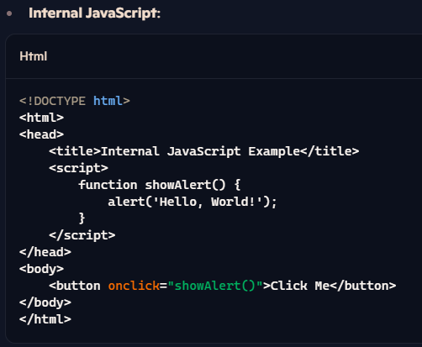

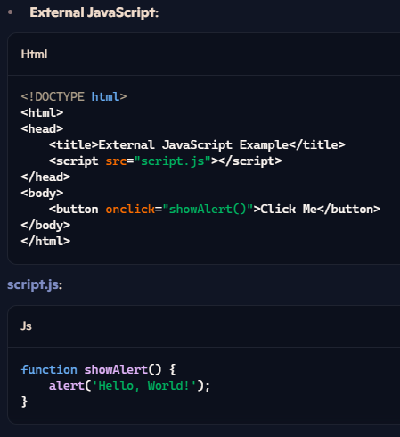

### ****1.2 Variables****

#### **Notes**:

* Variables store data and can be declared using var, let, or const.
* let and const are block-scoped (introduced in ES6), while var is function-scoped.

#### **Code and Explanation**:

1. **Declaring Variables**:

let name = "Alice"; // Modern way

const PI = 3.14; // Constant value

var age = 25; // Older way

console.log(name, age, PI);

1. **Differences**:
   * let: Can be reassigned but not redeclared within the same block.
   * const: Cannot be reassigned.
   * var: Can be reassigned and redeclared, but it's less preferred due to potential bugs.

### ****1.3 Data Types****

#### **Notes**:

* JavaScript has **primitive types** and **non-primitive types**:
  + **Primitive**: string, number, boolean, null, undefined, symbol, bigint.
  + **Non-primitive**: object (includes arrays, functions, etc.).

#### **Code and Explanation**:

let aString = "Hello"; // String

let aNumber = 42; // Number

let aBoolean = true; // Boolean

let anUndefined; // Undefined

let aNull = null; // Null

let anObject = { name: "Alice" }; // Object

console.log(typeof aString); // "string"

console.log(typeof aNumber); // "number"

console.log(typeof anObject); // "object"

console.log(typeof anUndefined); // "undefined"

### ****Chapter 3: Functions****

Functions are a fundamental building block in JavaScript. They are reusable blocks of code designed to perform specific tasks.

### ****3.1 Function and Function Expression****

#### **Theory**:

* **Function Declaration**: A standard way to define a function using the function keyword.
* **Function Expression**: Assigns a function (can be anonymous) to a variable.

#### **Code**:

// Function Declaration

function greet() {

console.log("Hello, World!");

}

greet(); // **Output: Hello, World!**

// Function Expression

const sayHello = function () {

console.log("Hello from Function Expression!");

};

sayHello(); // **Output: Hello from Function Expression**

* **Key Difference**: Function declarations are **hoisted**, meaning they can be called before they are defined. Function expressions are not.

### ****3.2 Function Parameters and Arguments****

#### **Theory**:

* **Parameters**: Variables listed in the function definition.
* **Arguments**: Values passed to the function when it's invoked.
* Functions can have **default parameters**, which assign a default value if no argument is provided.

#### **Code**:

// Function with parameters

function multiply(a, b = 1) { **// b has a default value of 1**

return a * b;

}

console.log(multiply(5, 10)); **// Output: 50**

console.log(multiply(5)); **// Output: 5 (b defaults to 1**)

### ****3.3 Return Statement****

#### **Theory**:

* The return statement sends a value back to the function caller and terminates the function execution.

#### **Code**:

function add(a, b) {

return a + b; **// Returns the sum of a and b**

}

const result = add(3, 7);

console.log(result); **// Output: 10**

function noReturn() {

console.log("No return here!");

}

console.log(noReturn()); **// Output: "No return here!" followed by undefined**

### ****3.4 Arrow Function****

#### **Theory**:

* Arrow functions, introduced in ES6, provide a shorter syntax.
* Arrow functions do not have their own this context, making them unsuitable for methods.

#### **Code**:

// Regular Function

const square = function (x) {

return x * x;

};

// Arrow Function

const squareArrow = (x) => x * x;

console.log(square(4)); **// Output: 16**

console.log(squareArrow(4)); **// Output: 16**

// Without parameters

const greet = () => console.log("Hello!");

greet(); **// Output: Hello!**

### ****3.5 Higher-Order Function - Callbacks****

#### **Theory**:

* A Higher-Order Function takes another function as an argument.
* A Callback Function is a function passed into another function as an argument.

#### **Code**:

function greet(name) {

console.log(`Hello, ${name}!`);

}

function executeCallback(callback, arg) {

callback(arg); **// Execute the passed function**

}

executeCallback(greet, "Alice"); **// Output: Hello, Alice!**

### ****3.7 IIFE (Immediately Invoked Function Expression)****

#### **Theory**:

* IIFE executes immediately after it's defined.
* Useful for creating a private scope to avoid polluting the global namespace.

#### **Code**:

(function () {

console.log("This is an IIFE!");

})(); **// Output: This is an IIFE!**

// With parameters

(function (name) {

console.log(`Hello, ${name}!`);

})("Alice"); **// Output: Hello, Alice!**

### ****3.8 setTimeout and setInterval****

#### **setTimeout Theory**:

* Executes a function after a specified delay (in milliseconds).

#### **setTimeout Code**:

console.log("Start");

setTimeout(() => {

console.log("Executed after 2 seconds");

}, 2000);

console.log("End");

**// Output:**

**// Start**

**// End**

**// Executed after 2 seconds**

#### **setInterval Theory**:

* Repeatedly executes a function at specified intervals.

#### **setInterval Code**:

let counter = 0;

const intervalId = setInterval(() => {

console.log(`Counter: ${++counter}`);

if (counter === 5) clearInterval(intervalId); **// Stops after 5 iterations**

}, 1000);

**// Output:**

**// Counter: 1**

**// Counter: 2**

**// Counter: 3**

**// Counter: 4**

**// Counter: 5**

### ****3.9 Hoisting****

#### **Theory**:

* **Hoisting** moves function declarations and variable declarations to the top of their scope during the compilation phase.
* Function expressions and variables using let or const are not hoisted.

#### **Code**:

// Function Declaration Hoisting

console.log(hello()); **// Output: "Hello!"**

function hello() {

return "Hello!";

}

// Function Expression (Not Hoisted)

console.log(sayHi); **// Output: undefined**

var sayHi = function () {

return "Hi!";

};

// let and const Hoisting

let myVar = 10;

console.log(myVar); **// ReferenceError: Cannot access 'myVar' before initialization**

### ****Summary****:

* Functions are reusable blocks of code.
* **Function Declarations** are hoisted, while **Function Expressions** are not.
* Arrow functions offer concise syntax and do not have their own this.
* Higher-order functions allow for dynamic programming through callbacks and function returns.
* Tools like **setTimeout** and **setInterval** enable asynchronous code execution.
* Hoisting affects how and when variables and functions are initialized.

### ****Chapter 4: Objects****

In JavaScript, **objects** are a collection of key-value pairs. They can store multiple values of different types and are essential for working with structured data. Objects are used extensively in JavaScript to represent real-world entities and more.

### ****4.1 Object Introduction****

#### **Theory**:

* Objects are a collection of properties (key-value pairs).
* Keys are strings (or symbols), and values can be any valid data type: primitive values, functions, or even other objects.

#### **Code**:

// Creating an object

const person = {

name: "John",

age: 30,

greet: function () {

console.log("Hello, " + this.name);

}

};

console.log(person.name); **// Output: John**

console.log(person.age); **// Output: 30**

person.greet(); **// Output: Hello, John**

### ****4.2 Function vs. Methods****

#### **Theory**:

* A **function** is a block of code designed to perform a task.
* A **method** is a function that is a property of an object.
* Functions can exist independently, while methods are associated with specific objects.

#### **Code**:

// Function

function greet() {

console.log("Hello!");

}

greet(); **// Output: Hello**!

// Object with Method

const person = {

name: "Alice",

greet: function () {

console.log("Hello, " + this.name);

}

};

person.greet(); **// Output: Hello, Alice**

### ****4.3 "this" Keyword****

#### **Theory**:

* The this keyword refers to the context of the function where it is called.
* In a regular function, this refers to the object from which the function was called.
* In an arrow function, this is lexically inherited from the surrounding context.

#### **Code**:

// Regular function

const person = {

name: "Alice",

greet: function () {

console.log("Hello, " + this.name); **// 'this' refers to the person object**

}

};

person.greet(); **// Output: Hello, Alice**

// Arrow function

const personArrow = {

name: "Bob",

greet: () => {

console.log("Hello, " + this.name); **// 'this' refers to the outer scope,** not the personArrow object

}

};

personArrow.greet();

**// Output: Hello, undefined (as 'this' refers to the global context in non-methods)**

### ****4.4 forEach Method****

#### **Theory**:

* forEach() is an array method used to execute a provided function once for each element in the array.
* It does not return a value (undefined is returned).

#### **Code**:

const numbers = [1, 2, 3, 4, 5];

numbers.forEach(function (num) {

console.log(num * 2);

});

**// Output:**

**// 2**

**// 4**

**// 6**

**// 8**

**// 10**

You can also use an arrow function:

numbers.forEach(num => console.log(num * 2));

**// Output: 2, 4, 6, 8, 10**

### ****4.5 Objects Inside Array****

#### **Theory**:

* You can store objects within an array.
* Arrays of objects are useful for organizing complex data structures like lists of people, products, etc.

#### **Code**:

const students = [

{ name: "John", age: 22 },

{ name: "Jane", age: 23 },

{ name: "Mike", age: 21 }

];

students.forEach(student => {

console.log(`${student.name} is ${student.age} years old`);

});

**// Output:**

**// John is 22 years old**

**// Jane is 23 years old**

**// Mike is 21 years old**

### ****4.6 Math Object****

#### **Theory**:

* The **Math** object provides properties and methods for mathematical constants and functions.
* It is a built-in object and does not need to be instantiated.

#### **Code**:

console.log(Math.PI); // Output: 3.141592653589793

console.log(Math.random()); // Output: A random number between 0 and 1

console.log(Math.pow(2, 3)); // Output: 8 (2 raised to the power of 3)

console.log(Math.sqrt(25)); // Output: 5 (square root of 25)

console.log(Math.round(4.5)); // Output: 5 (rounds to nearest integer)

### ****4.7 Call, Apply, and Bind****

#### **Theory**:

* These methods allow you to invoke functions with a specific this context.
  + **call()**: Invokes the function with a specified this value and arguments.
  + **apply()**: Similar to call(), but arguments are passed as an array.
  + **bind()**: Returns a new function with a specific this value, but does not invoke it immediately.

#### **Code**:

// Using call()

const person = { name: "Alice" };

function greet(greeting) {

console.log(greeting + ", " + this.name);

}

greet.call(person, "Hello"); **// Output: Hello, Alice**

// Using apply()

greet.apply(person, ["Hi"]); **// Output: Hi, Alice**

// Using bind()

const greetPerson = greet.bind(person, "Hey");

greetPerson(); **// Output: Hey, Alice**

### ****4.8 Pass by Value and Pass by Reference****

#### **Theory**:

* **Pass by Value**: When primitive values (e.g., numbers, strings, booleans) are passed to a function, they are copied, and changes inside the function do not affect the original value.
* **Pass by Reference**: When objects are passed to a function, the reference (memory address) of the object is passed, meaning changes affect the original object.

#### **Code**:

**// Pass by Value**

let a = 10;

function changeValue(x) {

x = 20;

}

changeValue(a);

console.log(a); **// Output: 10 (the original value is unchanged)**

**// Pass by Reference**

let person = { name: "John", age: 25 };

function changePerson(obj) {

obj.age = 26;

}

changePerson(person);

console.log(person.age); **// Output: 26 (the original object is modified)**

### ****4.9 for-in Loop****

#### **Theory**:

* The for-in loop is used to iterate over the properties of an object.
* It loops through all enumerable properties of the object, including those that are inherited through the prototype chain.

#### **Code**:

const person = {

name: "Alice",

age: 25,

greet: function () {

console.log("Hello!");

}

};

for (let key in person) {

console.log(key + ": " + person[key]);

}

**// Output:**

**// name: Alice**

**// age: 25**

**// greet: function() { console.log("Hello!");** }

**// To avoid inherited properties, you can use hasOwnProperty()**

for (let key in person) {

if (person.hasOwnProperty(key)) {

console.log(key + ": " + person[key]);

}

}

### ****Chapter 5: DOM (Document Object Model)****

### **Chapter 5: DOM** 5.1 DOM Introduction 5.2 Query Selector 5.3 Other Ways to Access Elements

### The **DOM** (Document Object Model) is a programming interface for web documents. It represents the page so that programs can manipulate the structure, style, and content of web pages. The DOM represents a page as a tree structure where each node is an object representing a part of the page. ****5.1 DOM Introduction****

#### **Theory**:

* The **DOM** allows JavaScript to access and update the content, structure, and style of HTML documents.
* JavaScript interacts with the DOM to dynamically update web pages without requiring a page reload.
* The DOM represents the HTML structure as a hierarchy of nodes (elements, attributes, text, etc.).

#### **Code Example**:

<!DOCTYPE html>

<html lang="en">

<head>

<meta charset="UTF-8">

<title>DOM Example</title>

</head>

<body>

<div id="myDiv">Hello, DOM!</div>

<script>

**// Accessing the DOM element**

const div = document.getElementById("myDiv");

console.log(div.textContent); // Output: Hello, DOM!

**// Modifying the DOM element"**

div.textContent = "Hello, JavaScript!";

</script>

</body>

</html>

### ****5.2 Query Selector****

#### **Theory**:

* querySelector() is a method used to select an element from the DOM using CSS selectors.
* It returns the first matching element, or null if no matching element is found.

#### **Code Example**:

<!DOCTYPE html>

<html lang="en">

<head>

<meta charset="UTF-8">

<title>Query Selector Example</title>

</head>

<body>

<p class="message">This is a paragraph.</p>

<p id="intro">Another paragraph.</p>

<script>

**// Using querySelector to select by class**

const message = document.querySelector(".message");

console.log(message.textContent); // Output: This is a paragraph.

**// Using querySelector to select by ID**

const intro = document.querySelector("#intro");

console.log(intro.textContent); // Output: Another paragraph.

</script>

</body>

</html>

#### **Code Example**:

html

Copy code

<!DOCTYPE html>

<html lang="en">

<head>

<meta charset="UTF-8">

<title>DOM Example</title>

</head>

<body>

<div id="myDiv">Hello, DOM!</div>

<script>

// Accessing the DOM element

const div = document.getElementById("myDiv");

console.log(div.textContent); // Output: Hello, DOM!

// Modifying the DOM element

div.textContent = "Hello, JavaScript!";

</script>

</body>

</html>

### ****5.2 Query Selector****

#### **Theory**:

* querySelector() is a method used to select an element from the DOM using CSS selectors.
* It returns the first matching element, or null if no matching element is found.

#### **Code Example**:

html

Copy code

<!DOCTYPE html>

<html lang="en">

<head>

<meta charset="UTF-8">

<title>Query Selector Example</title>

</head>

<body>

<p class="message">This is a paragraph.</p>

<p id="intro">Another paragraph.</p>

<script>

// Using querySelector to select by class

const message = document.querySelector(".message");

console.log(message.textContent); // Output: This is a paragraph.

// Using querySelector to select by ID

const intro = document.querySelector("#intro");

console.log(intro.textContent); // Output: Another paragraph.

</script>

</body>

</html>

### ****5.3 Other Ways to Access Elements****

#### **Theory**:

Besides querySelector(), there are other methods to access DOM elements:

* getElementById(): Selects an element by its ID.
* getElementsByClassName(): Selects elements by their class name.
* getElementsByTagName(): Selects elements by their tag name.

#### **Code Example**:

html

Copy code

<!DOCTYPE html>

<html lang="en">

<head>

<meta charset="UTF-8">

<title>Access Methods</title>

</head>

<body>

<div id="container">

<p class="text">First paragraph.</p>

<p class="text">Second paragraph.</p>

</div>

<script>

// Using getElementById

const container = document.getElementById("container");

console.log(container);

// Using getElementsByClassName (returns a live HTMLCollection)

const paragraphs = document.getElementsByClassName("text");

console.log(paragraphs[0].textContent); // Output: First paragraph.

</script>

</body>

</html>

**Chapter 4: Objects**  
4.1 Object Introduction  
4.2 Function vs. Methods  
4.3 "this" Keyword  
4.4 for-Each Method  
4.5 Objects Inside Array  
4.6 Math Object  
4.7 Call, Apply, and Bind  
4.8 Pass by Value and Pass by Reference  
4.9 for-in Loop

### Chapter 4: Objects

#### 4.1 Object Introduction

**Definition**: An object is a collection of properties, where each property is defined as a key-value pair. Objects can store data and functions, making them essential for organizing complex data structures in JavaScript.

Code Example

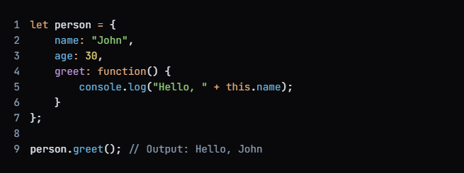

4.2 Function vs. Methods

**Definition**: A function is a standalone block of code that can be executed independently, while a method is a function that is associated with an object. Methods can manipulate the object's properties and provide behavior specific to that object.

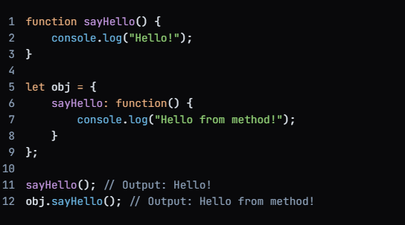

**4.3 "this" Keyword**

**Definition: The this keyword refers to the current object in which the code is executing. Its value can change based on the context in which a function is called, making it crucial for object-oriented programming.**

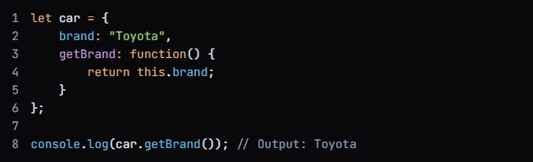

#### **4.4 for-Each Method**

**Definition: The forEach method is an array method that executes a provided function once for each array element. It simplifies the process of iterating over arrays and is often preferred for its readability.**

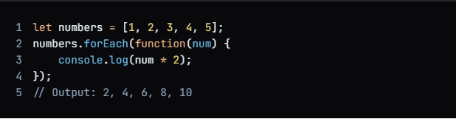

**4.5 Objects Inside Array**

**Definition**: Arrays can contain objects as their elements, allowing for the creation of complex data structures. This is useful for representing collections of related data, such as a list of students with their attributes.

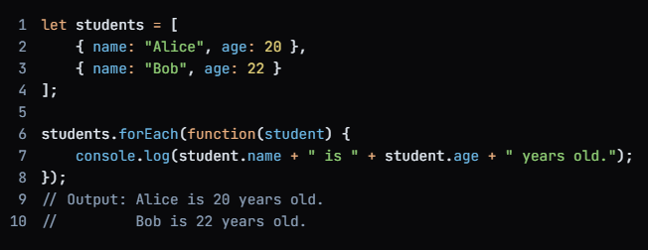

**4.6 Math Object**

**Definition**: The Math object provides a set of mathematical functions and constants that are built into JavaScript. It allows developers to perform complex calculations without needing to implement these functions manually.

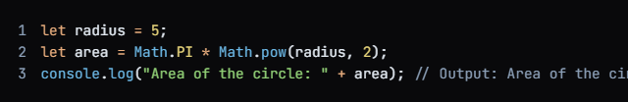

**4.7 Call, Apply, and Bind**

**Definition: These methods allow you to control the value of this in functions. call and apply invoke a function with a specified this value, while bind creates a new function with a fixed this value, which can be called later.**

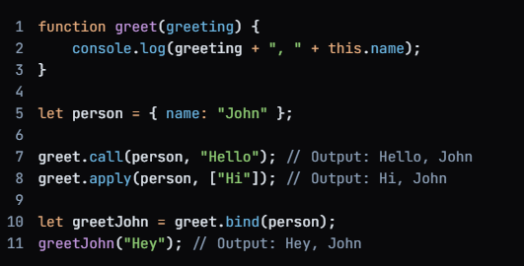

4.8 Pass by Value and Pass by Reference

**Definition**: In JavaScript, primitive data types (like numbers and strings) are passed by value, meaning a copy is made. In contrast, objects and arrays are passed by reference, allowing functions to modify the original object.

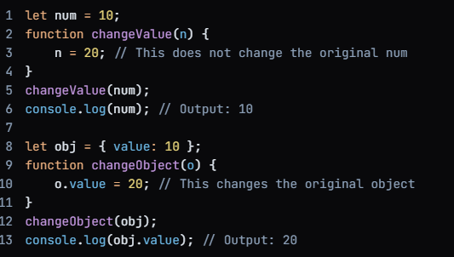

4.9 **The for-in loop** :

iterates over all enumerable properties of an object, including those inherited from its prototype chain.

It is important to use the **hasOwnProperty** method to filter out properties that are inherited from the prototype chain if you only want to work with the object's own properties.

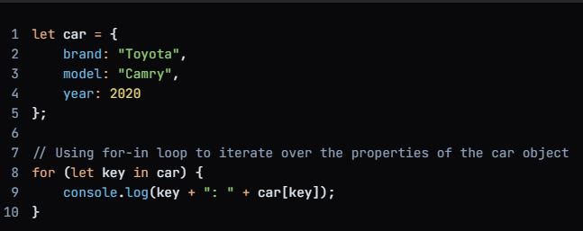

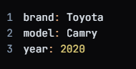

TASK 🡪

Style color :

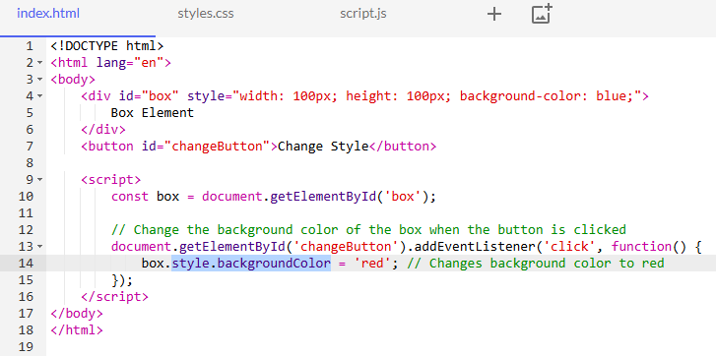

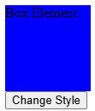

After click :->

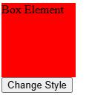

In addition to the common methods like getElementById(), there are other ways to access elements in the DOM. These methods are useful depending on what you're trying to achieve.

#### **1. getElementsByClassName(class)**

* **Explanation**:  
  This method returns a **live collection** of elements with the given class name. The collection is "live," meaning it updates automatically when the DOM changes.

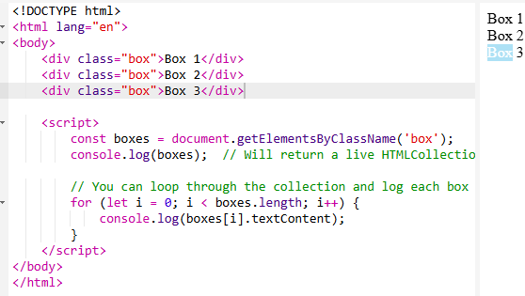

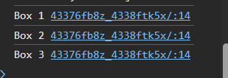

#### **2.** getElementsByTagName(tag)

* **Explanation**:  
  This method returns a **live collection** of all elements with the specified tag name (e.g., div, p, etc.).

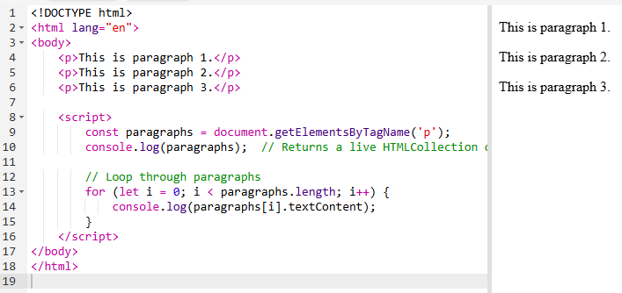

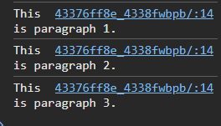

**Chapter 6: DOM - Forms**  
6.1 Submit Event  
6.2 Regular Expression  
6.3 Basic Form Validation  
6.4 Keyboard Event

### 6.1 Submit Event

**Theory:** The submit event is triggered when a form is submitted. This event can be used to execute JavaScript when the form is submitted, such as validating form data before sending it to the server.

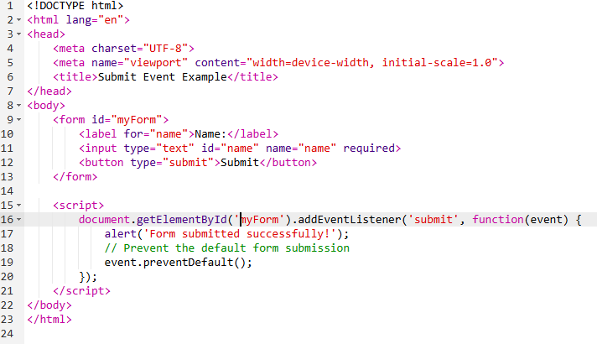



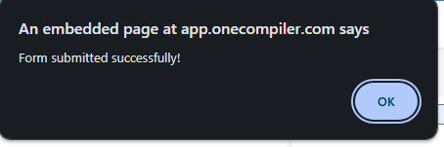

Example 🡪

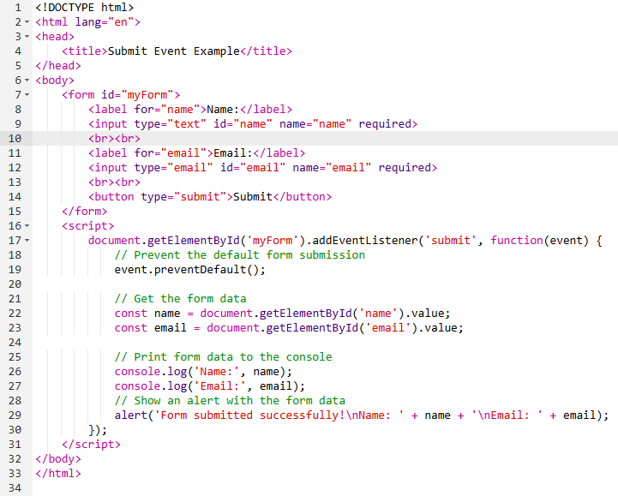

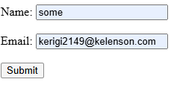 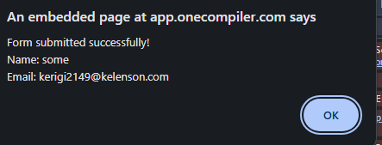



### 6.2 Regular Expression

**Theory:** Regular expressions (regex) are patterns used to match character combinations in strings. They are often used for form validation to ensure that user input matches a specific pattern, such as an email address or phone number.

Phone Number 🡪

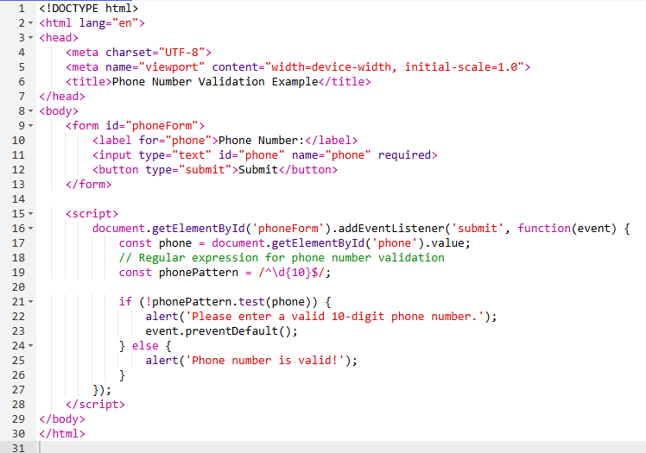

Incorrect   


Correct



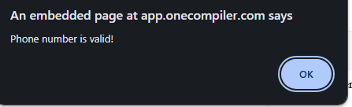

### 6.3 Basic Form Validation

**Theory:** Basic form validation is a way to ensure that user input meets certain criteria before the form is submitted. This includes checking if required fields are filled, if input values match specific patterns, and if values fall within a particular range. This helps in preventing incorrect or incomplete data submission.

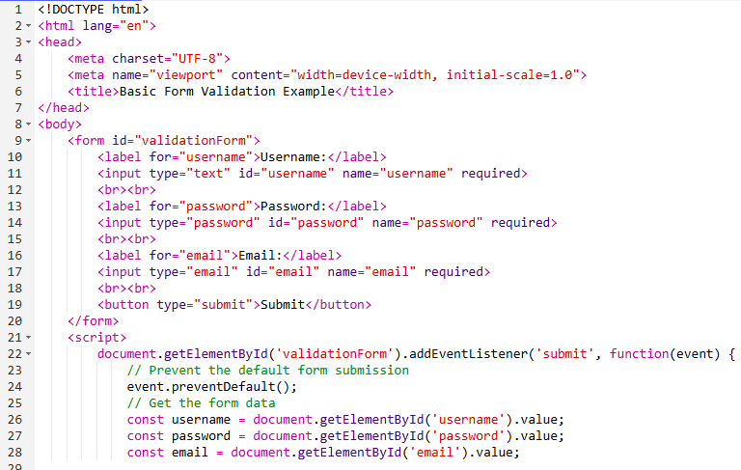

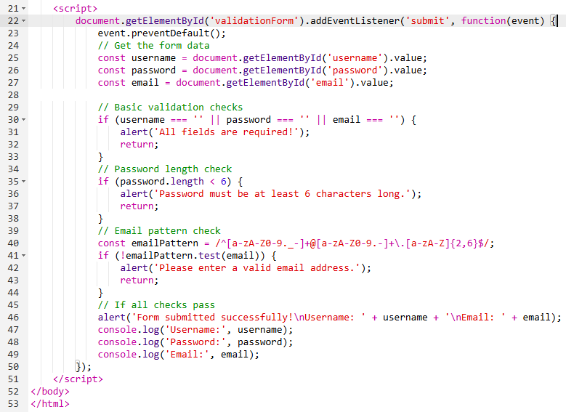

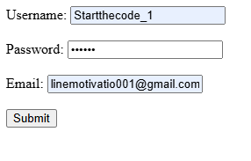

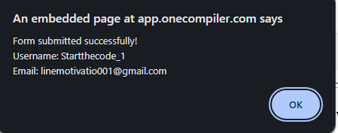

### 6.4 Keyboard Event

**Theory:** Keyboard events are events triggered by keyboard actions, such as pressing, releasing, or holding down a key. Common keyboard events include keydown, keyup, and keypress. These events are useful for capturing user input, creating keyboard shortcuts, and enhancing user interactions on a webpage.

### Common Keyboard Events:

1. **keydown**: Triggered when a key is pressed down.
2. **keyup**: Triggered when a key is released.
3. **keypress**: Triggered when a key is pressed down and that key produces a character value (deprecated, keydown is preferred).

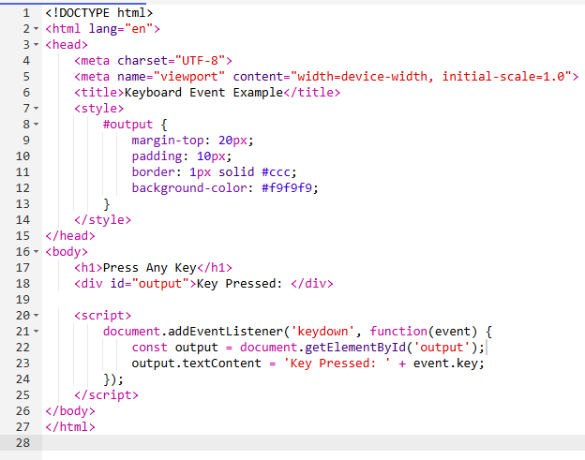

Detect All Keyword keys

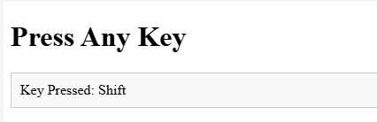

**Chapter 7: Array Methods**  
7.0 Array Methods  
7.1 Slice  
7.2 Splice  
7.3 At  
7.4 Map  
7.5 Filter

### 7.0 Array Methods

Array methods in JavaScript are functions that can be called on arrays to perform various operations. They help in manipulating and processing array data efficiently.

### 7.1 Slice

**Theory:** The slice() method returns a shallow copy of a portion of an array into a new array object. It takes two arguments: start and end (optional). The end index is not included in the new array.

**Example:**

**const fruits = ['apple', 'banana', 'cherry', 'date'];**

**const slicedFruits = fruits.slice(1, 3);**

**console.log(slicedFruits);**

**// Output: ['banana', 'cherry']**

### 7.2 Splice

**Theory:** The splice() method changes the contents of an array by removing or replacing existing elements and/or adding new elements in place. It takes at least two arguments: start and deleteCount.

**Example:**

Javascript 🡪

const fruits = ['apple', 'banana', 'cherry', 'date'];

const removedFruits = fruits.splice(1, 2, 'blueberry', 'citrus');

console.log(fruits);

// Output: ['apple', 'blueberry', 'citrus', 'date']

console.log(removedFruits);

// Output: ['banana', 'cherry']

### 7.3 At

**Theory:** The at() method takes an integer value and returns the item at that index. It supports negative integers to count back from the last item in the array.

**Example:**

javascript

const fruits = ['apple', 'banana', 'cherry', 'date'];

console.log(fruits.at(1)); // Output: 'banana'

console.log(fruits.at(-1)); // Output: 'date'

### 7.4 Map

**Theory:** The map() method creates a new array populated with the results of calling a provided function on every element in the calling array.

**Example:**

javascript

const numbers = [1, 2, 3, 4];

const doubled = numbers.map(num => num * 2);

console.log(doubled); // Output: [2, 4, 6, 8]

**for DIRECT USE 🡪**

**Code o/p in NaN**



### 7.5 Filter

**Theory:** The filter() method creates a new array with all elements that pass the test implemented by the provided function.

**Example:**

const numbers = [1, 2, 3, 4, 5];

const evenNumbers = numbers.filter(num => num % 2 === 0);

console.log(evenNumbers); // Output: [2, 4]

### 7.6 Reduce

**Theory:** The reduce() method executes a reducer function on each element of the array, resulting in a single output value. It takes a callback function and an initial value.

**Example:**

Javascript

const numbers = [1, 2, 3, 4];

const sum = numbers.reduce((accumulator, currentValue) => accumulator + currentValue, 0);

console.log(sum); // Output: 10

*Logic

• **reduce ka kaam:**  
Yeh array ke elements ko ek single value mein reduce karta hai, yahan hum elements ka sum nikaal rahe hain.

• **Parameters:**  
reduce method ko ek callback function aur ek initial value pass hoti hai.  
**Callback Function Parameters:**

* **accumulator:** Yeh previous iteration ka result ya initial value hota hai.
* **currentValue:** Yeh array ka current element hota hai.

• **Initial Value:**  
Callback function ke pehle argument (accumulator) ki initial value set karne ke liye ek value pass ki jati hai. Yahan wo 0 hai.

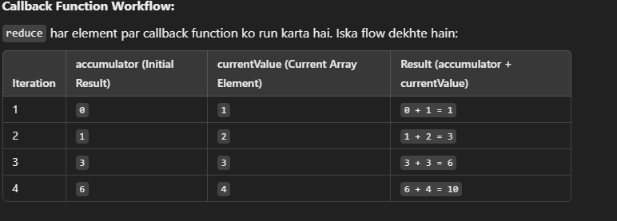

### 7.7 Find

**Theory:** The find() method returns the value of the first element in the array that satisfies the provided testing function. If no values satisfy the testing function, undefined is returned.

**Example:**

const numbers = [1, 2, 3, 4, 5];

const found = numbers.find(num => num > 3);

console.log(found); // Output: 4

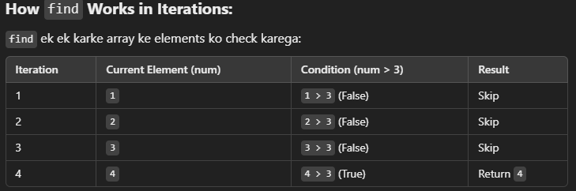

O/p is 4.

### 7.8 FindIndex

**Theory:** The findIndex() method returns the index of the first element in the array that satisfies the provided testing function. If no elements satisfy the testing function, -1 is returned.

**Example:**

javascript

const numbers = [1, 2, 3, 4, 5];

const index = numbers.findIndex(num => num > 3);

console.log(index); // Output: 3

logic🡪

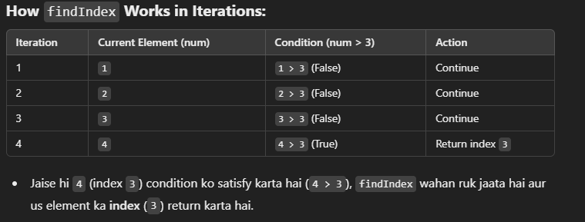

**Chapter 8: Date**  
8.1 Date and Time

### Chapter 8: Date and Time

Understanding how to work with dates and times is essential for many programming tasks, from displaying the current date to calculating durations or time differences. JavaScript provides a built-in Date object that simplifies these tasks.

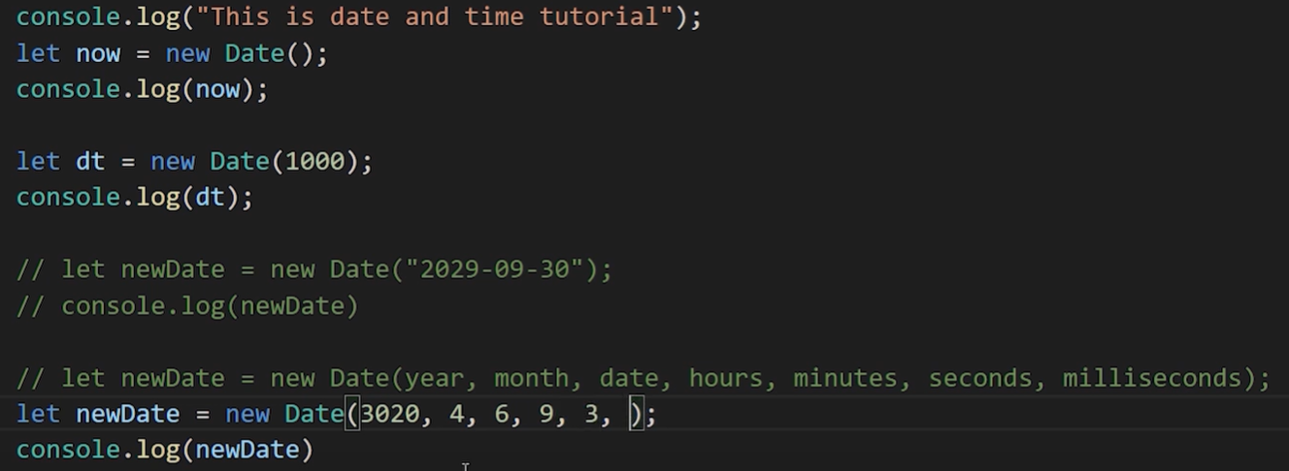

DATE 🡪

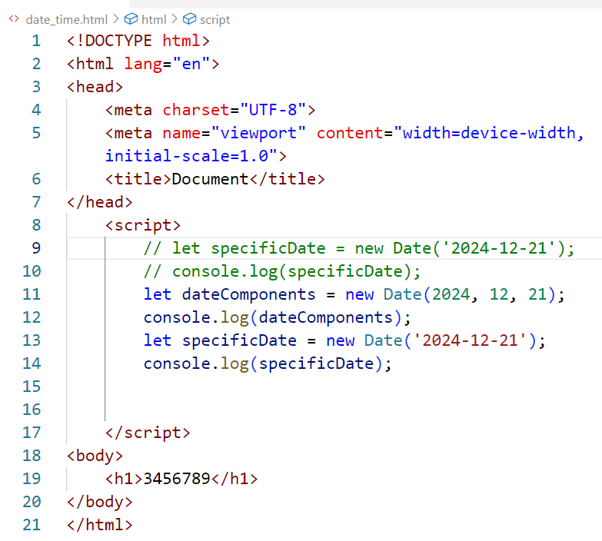

Month Starting index in 0;

o/p 🡪 ?

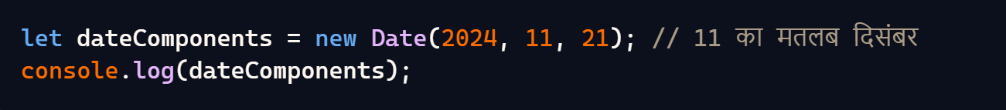

### Date Methods in JavaScript

Here is a comprehensive list of the various methods available in the Date object in JavaScript, along with their usage and why you might use them:

#### 1. getFullYear()

* **Usage**: Retrieves the year (4 digits for 4-digit years) from a date.
* **Why**: To get the current year or the year from a specific date.

let now = new Date();

console.log(now.getFullYear()); // Outputs: 2023

#### 2. getMonth()

* **Usage**: Retrieves the month from a date (0-11, where 0 is January and 11 is December).
* **Why**: To get the current month or the month from a specific date.

javascript

let now = new Date();

console.log(now.getMonth()); // Outputs: 3 (April)

explain :-



Because current date is 21-12-2024   
So o/p is November .

Because month starting is 0 indexing .

#### 3. getDate()

* **Usage**: Retrieves the day of the month from a date (1-31).
* **Why**: To get the current day or the day from a specific date.

javascript

let now = new Date();

console.log(now.getDate()); // Outputs: 21

because Current date is 21 .

#### 4. getDay()

* **Usage**: Retrieves the day of the week from a date (0-6, where 0 is Sunday and 6 is Saturday).
* **Why**: To get the current weekday or the weekday from a specific date.

javascript

let now = new Date();

console.log(now.getDay()); // Outputs: 6 (because today is Saturday)

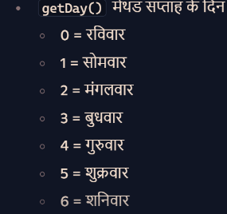

#### 5. setMinutes(minutes, [seconds], [milliseconds])

* **Usage**: Sets the minutes for a date object, optionally setting seconds and milliseconds.
* **Why**: To change the minutes of a specific date.

javascript

let now = new Date();

now.setMinutes(45, 0, 0);

console.log(now); // Date object now represents 45 minutes

**Chapter 9: LocalStorage**  
9.1 Local Storage Introduction  
  
9.1 Local Storage Introduction in JavaScript

**Theory:** Local Storage is a web storage feature that allows you to store data on the client's browser with no expiration date. This data persists even after the browser is closed and reopened. Local Storage provides a **simple key-value pair storage system**, making it useful for saving user preferences, session data, and other information that needs to be maintained across page loads.

Simple Example :->

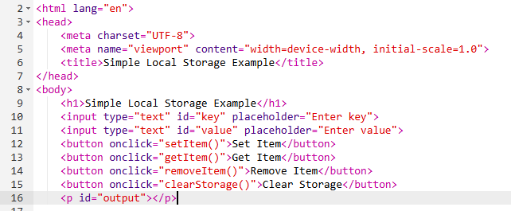

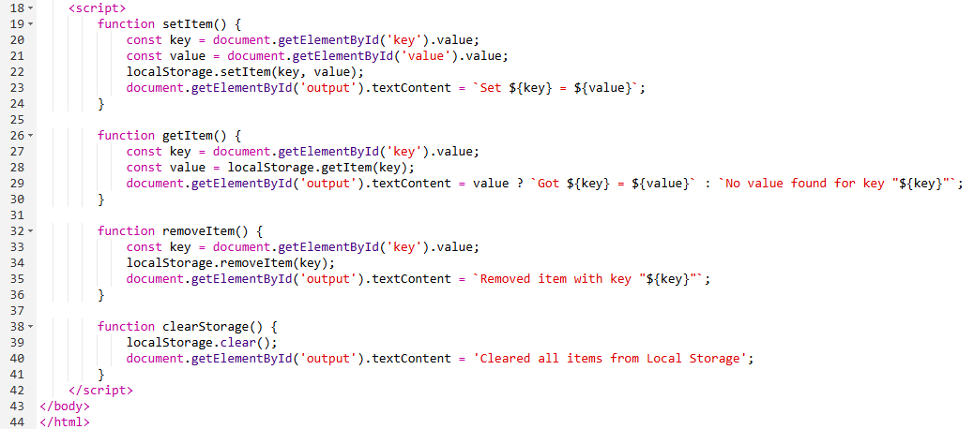

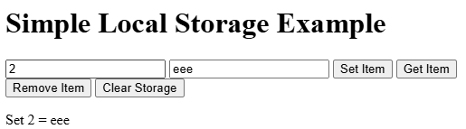

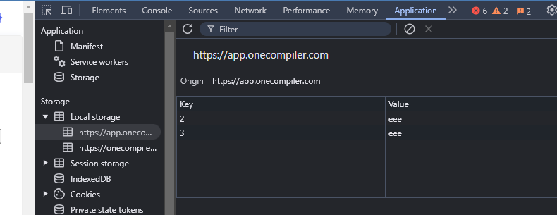

Get

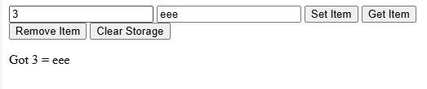

Clear Storage :

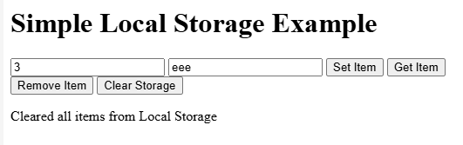

Another :

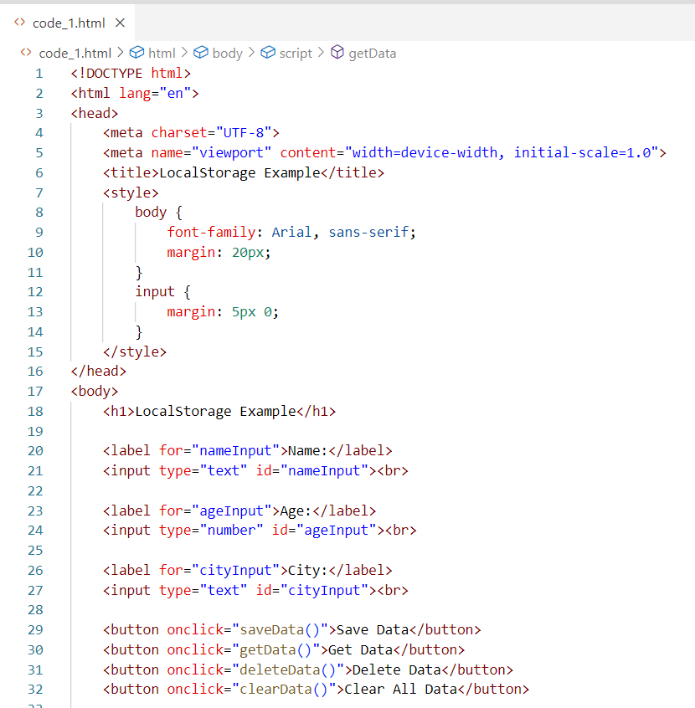

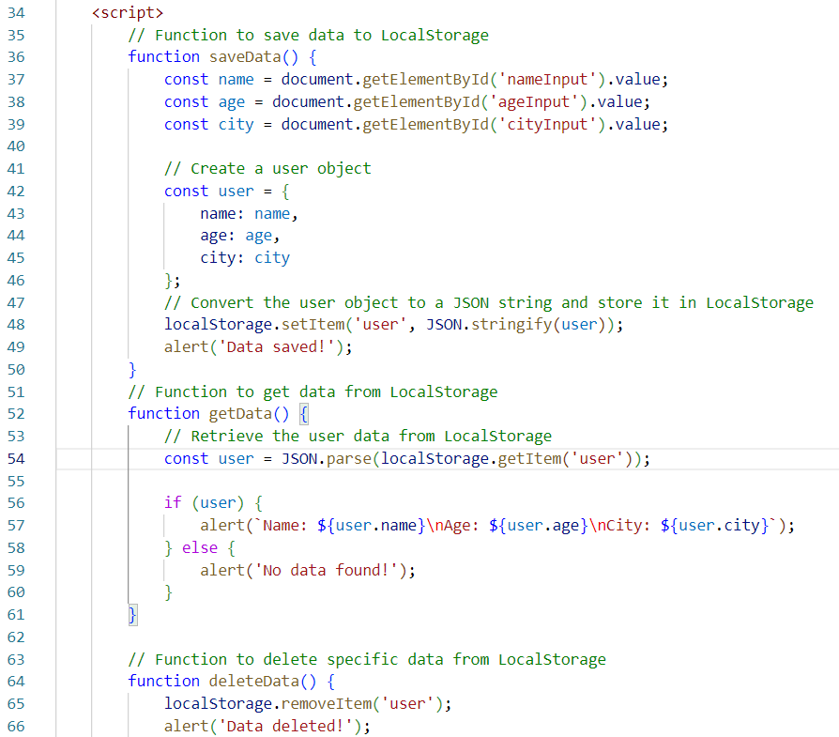

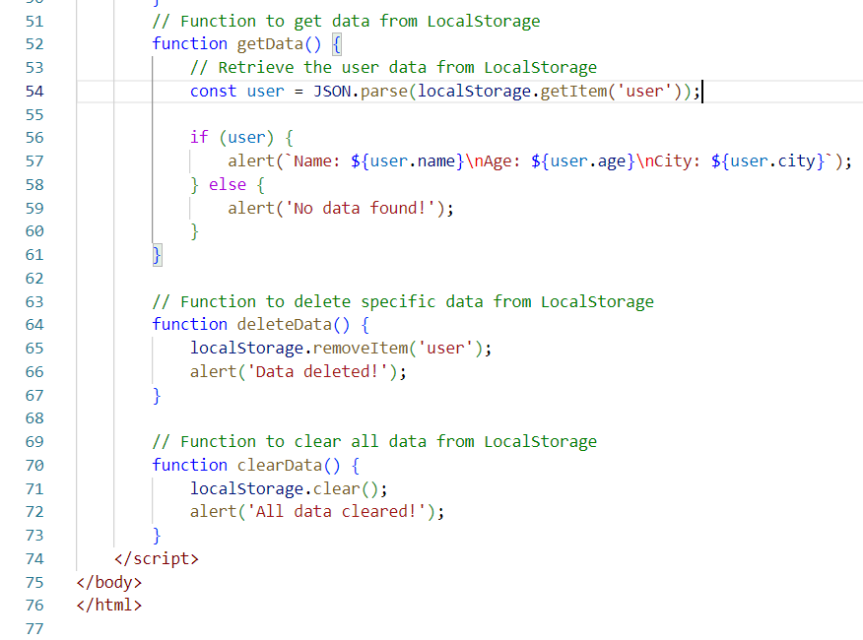

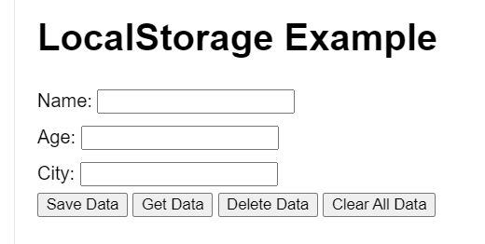

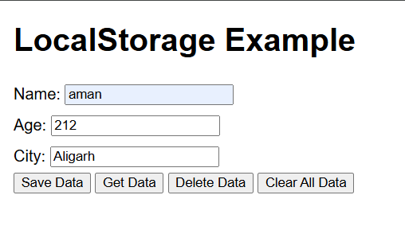

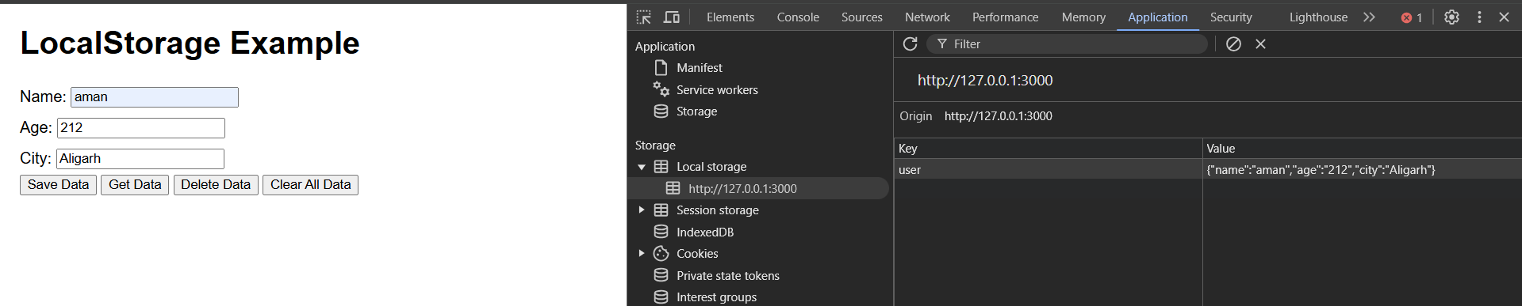

**Chapter 10: OOP**  
10.1 Constructor and new Operator  
10.2 Prototypes  
10.3 Prototypical Inheritance  
10.4 ES6 Classes  
10.5 Setters and Getters  
10.6 Static Methods  
10.7 Class Inheritance  
10.8 Inheritance by Prototypes  
10.9 Chaining of Methods

**Chapter 10: Object-Oriented Programming (OOP)**

### Simple Example of Objects and Classes

**Theory:**

1. **Object:** An object is an instance of a class. It encapsulates data (attributes) and methods (functions) that operate on the data.
2. **Class:** A class is a blueprint for creating objects. It defines properties and behaviors that the objects created from the class will have.

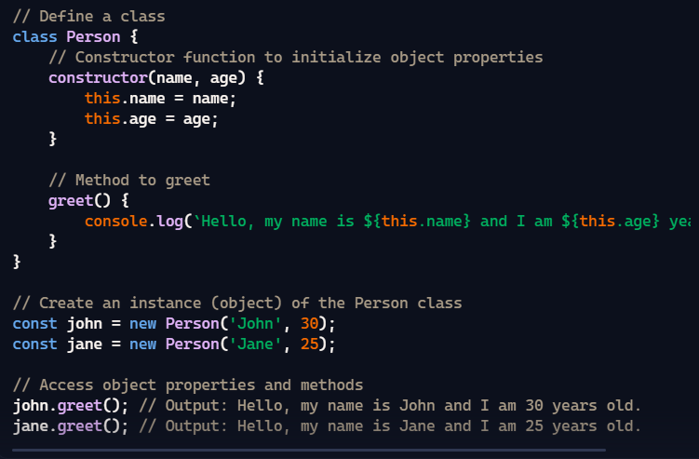

**Without object use for this code , using static keyword 🡪  
  
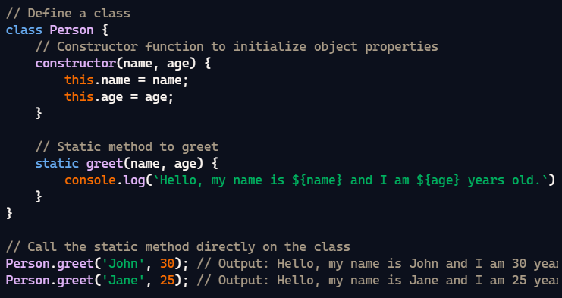**

• **Static Method:** The greet method is defined as a static method using the static keyword.

• **Calling the Method:** Static methods are called on the class itself rather than on instances of the class. Therefore, you can call Person.greet('John', 30) directly without creating an instance.

**Pillars**

**Inheritance**

Inheritance allows a class to inherit properties and methods from another class, promoting code reusability.

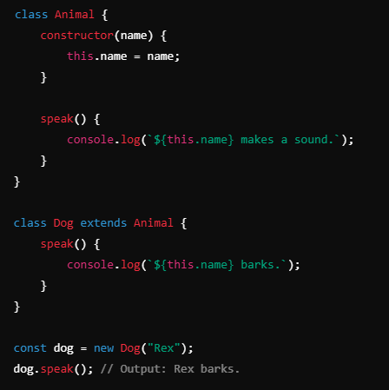

Here's a breakdown of what each part does:

* **class Person { ... }**: This defines a new class named Person.
* **constructor(name) { ... }**: The constructor is a special function that gets called whenever a new instance of the Person class is created. It takes a parameter name.
* **this.name = name;**: Inside the constructor, this refers to the new instance being created. This line sets the name property of the instance to the value passed as the name parameter.

**Polymorphism** allows objects of different classes to be treated as objects of a common superclass. It enables a single interface to represent different underlying forms (data types).

**Theory**: Polymorphism allows objects of different classes to be treated as objects of a common superclass. It enables the use of methods with the same name but potentially different implementations in different classes. In JavaScript, polymorphism is typically implemented using method overriding, where a subclass redefines a method from its parent class.

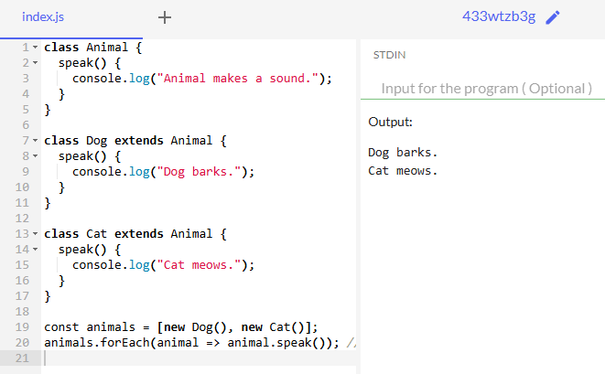

**Abstraction:**  
**Theory**: Abstraction is the process of hiding the complex implementation details and showing only the essential features of an object. It allows the developer to focus on the higher-level functionality without worrying about the internal workings. In JavaScript, abstraction is often achieved through the use of classes and methods that provide a simplified interface.  
  
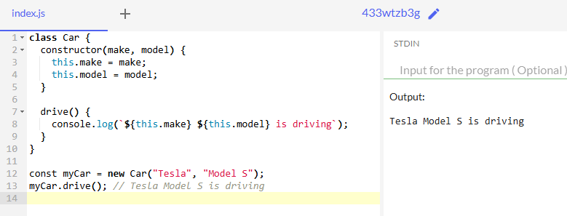

### What is Inheritance?

**Inheritance** in object-oriented programming (OOP) allows a class (child class) to **inherit** properties and methods from another class (parent class). This helps avoid repeating code and promotes code reuse.

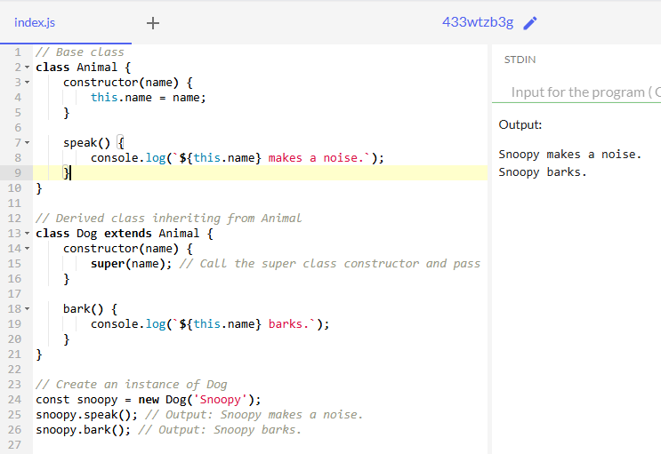

**ENCAPSULATION :**

10.1 Constructor and new Operator

### Constructor and new Operator in JavaScript

In JavaScript, constructors and the new operator are used to create and initialize objects. Let's break down these concepts clearly:

### 1. ****Constructor in JavaScript****

A **constructor** is a special function used to initialize objects created from a class or function. It is automatically called when a new object is created using the new keyword.

* **For Classes**: A constructor is a special method in a class that gets called when an object of that class is created.
* **For Functions (Pre-ES6)**: Functions can also act as constructors when used with the new keyword.

### 2. ****The**** new ****Operator****

The new operator is used to create an instance of a class or a function (used as a constructor). When new is used:

1. A new empty object is created.
2. The constructor function is called with this referring to the newly created object.
3. The newly created object is returned from the constructor (unless the constructor explicitly returns another object).

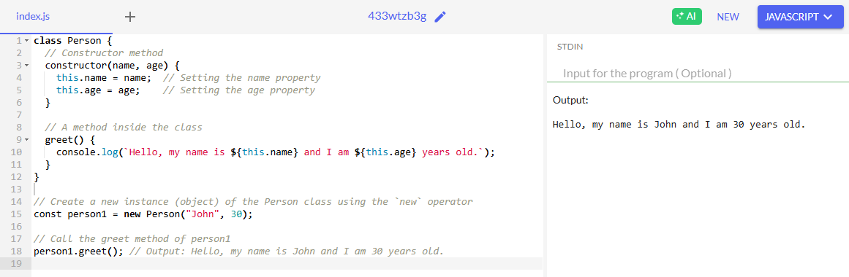

10.2 Prototypes

**Concept**: Prototypes are a fundamental feature in JavaScript that allows objects to inherit properties and methods from other objects. Every JavaScript object has a prototype, which is another object that the original object inherits properties from.

**Why Use Prototypes?** :

* **Inheritance**: Allows objects to share properties and methods, promoting code reuse.
* **Efficient Memory Usage**: Methods can be defined once on the prototype and shared by all instances, rather than defining them on each instance separately.
* **Dynamic Updates**: Adding or modifying methods on the prototype automatically updates all instances that inherit from it.

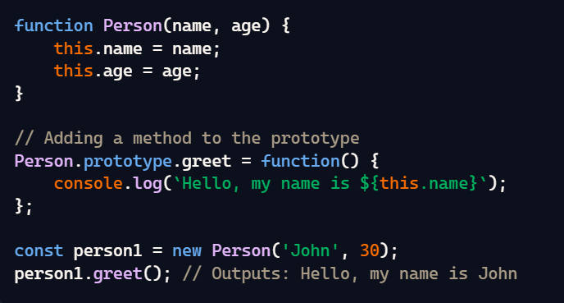

**Without Prototype**

When we don't use prototypes, each object instance has its own copy of methods, which can lead to redundant memory usage.

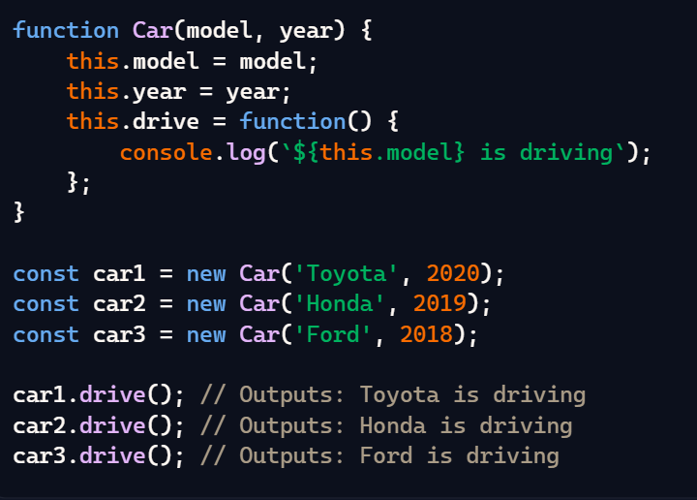

**With Prototype 🡪**  
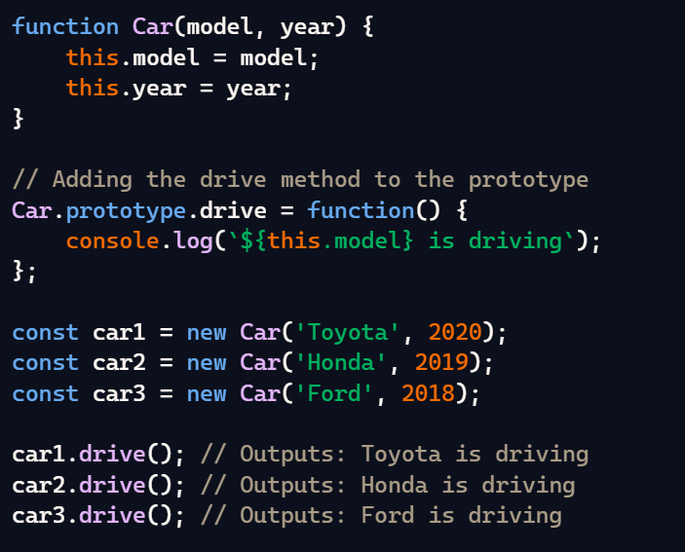

**Another Example : 🡪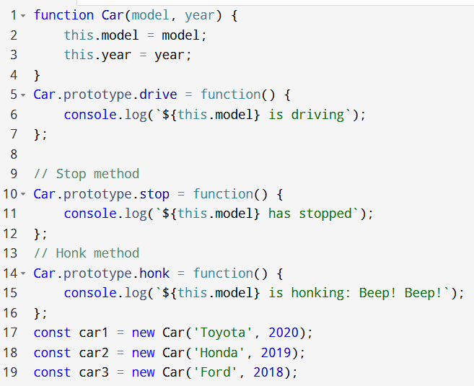 o/p 🡪**

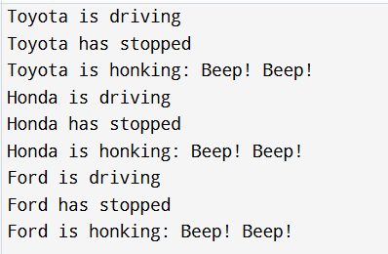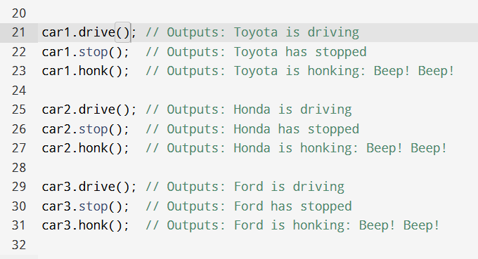

### 10.3 Prototypical Inheritance

**Theory**: Prototypical Inheritance is a core concept in JavaScript where objects can inherit properties and methods from other objects. This is achieved through the prototype chain, which allows objects to reference other objects' properties and methods.

**Prototypical Inheritance** enables:

1. **Inheritance**: Objects inherit properties and methods from their prototypes.
2. **Prototype Chain**: If a property or method is not found on an object, JavaScript looks up the prototype chain to find it.
3. **Dynamic Nature**: Prototypes can be modified at runtime, and changes are reflected in all inheriting objects
4. **Prototypical Inheritance (Theory and Code)**
5. Prototypical inheritance is a fundamental concept in JavaScript. It allows objects to inherit properties and methods from other objects. This differs from classical inheritance (used in languages like Java or C++) because, in JavaScript, every object has a prototype (another object), and it can inherit properties and methods from that prototype.

Without use 🡪

**Example without Using Object.create() (Prototype Property):**

In this example, we won't use Object.create(), but we'll manually set up the prototype inheritance.

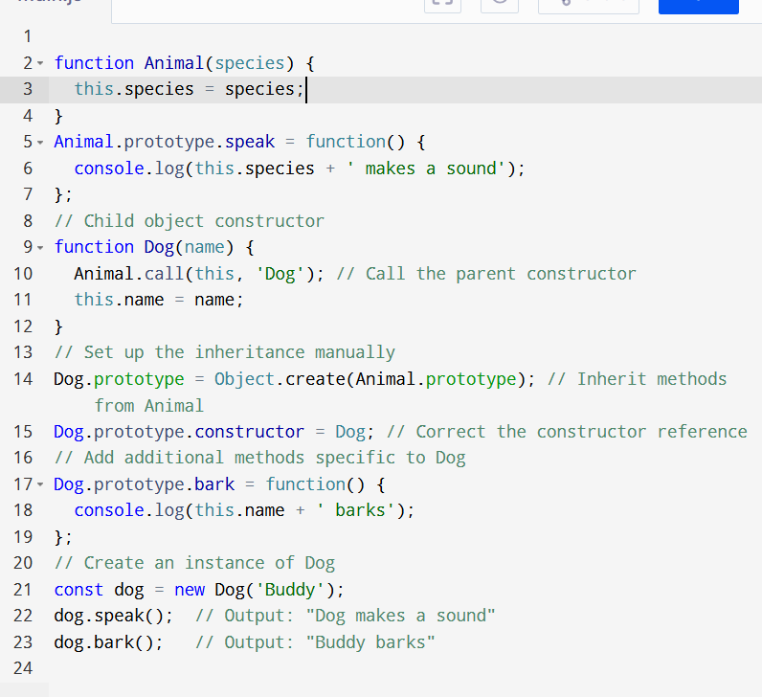

Use 🡪

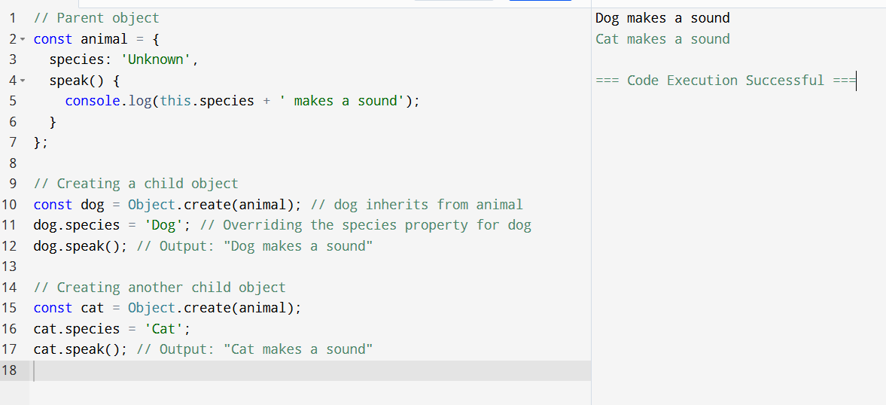

The code is very easy and simple

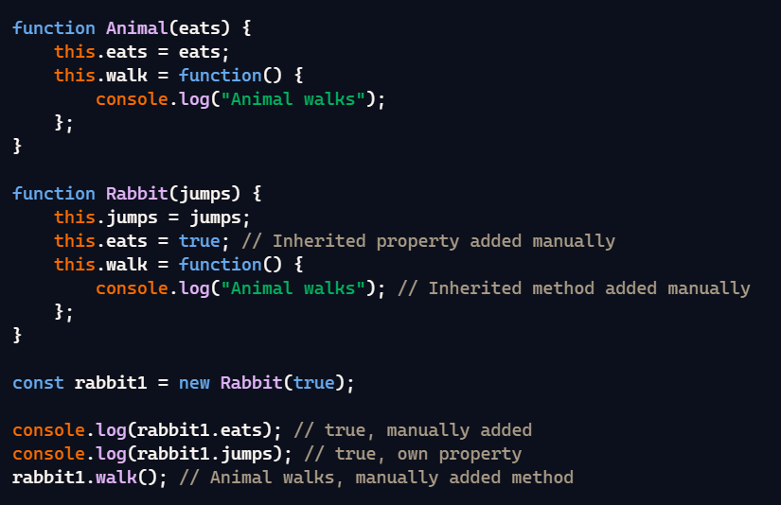

### 10.4 ES6 Classes

**Theory**: ES6 (ECMAScript 2015) introduced a class syntax that provides a clearer and more concise way to create objects and handle inheritance. Although classes in JavaScript are syntactic sugar over the prototypical inheritance model, they make the code more readable and maintainable.

#### Features of ES6 Classes:

1. **Class Declaration**: Use the class keyword to define a class.
2. **Constructor Method**: A special method for creating and initializing objects created within a class.
3. **Inheritance**: Use the extends keyword to create a subclass.
4. **Super**: Use the super keyword to call the constructor and methods of the parent class.

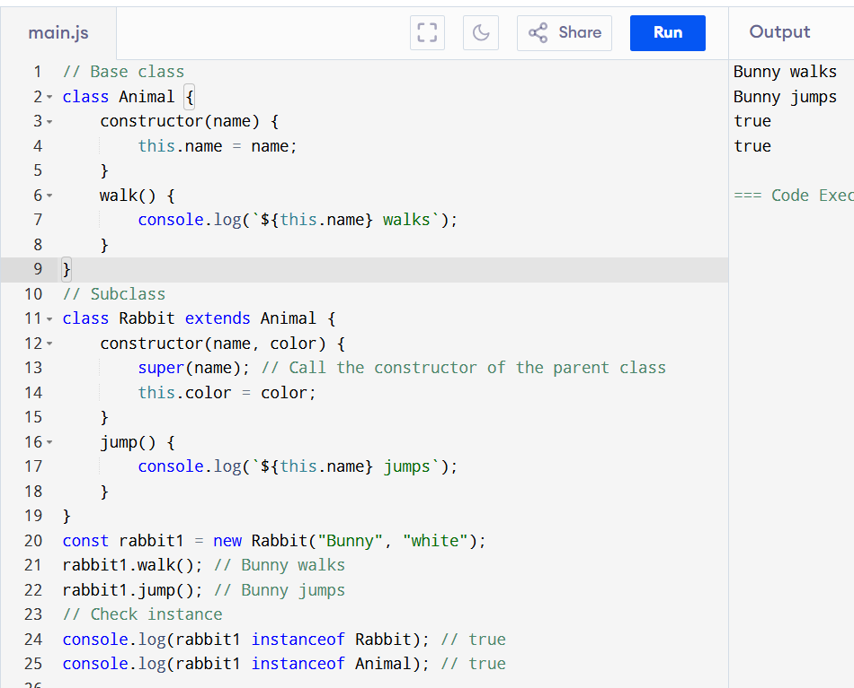

Using Super Keyword (simple Code and simple logic)

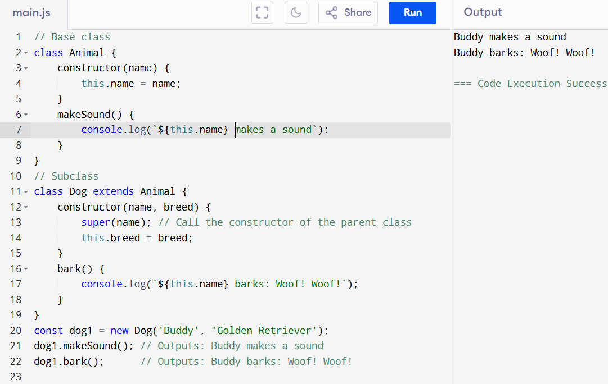

**10.5 Setters and Getters**

**Theory**: Setters and getters are special methods in JavaScript that allow you to define how properties of an object are accessed and updated. They are useful for adding extra logic when reading or setting property values.

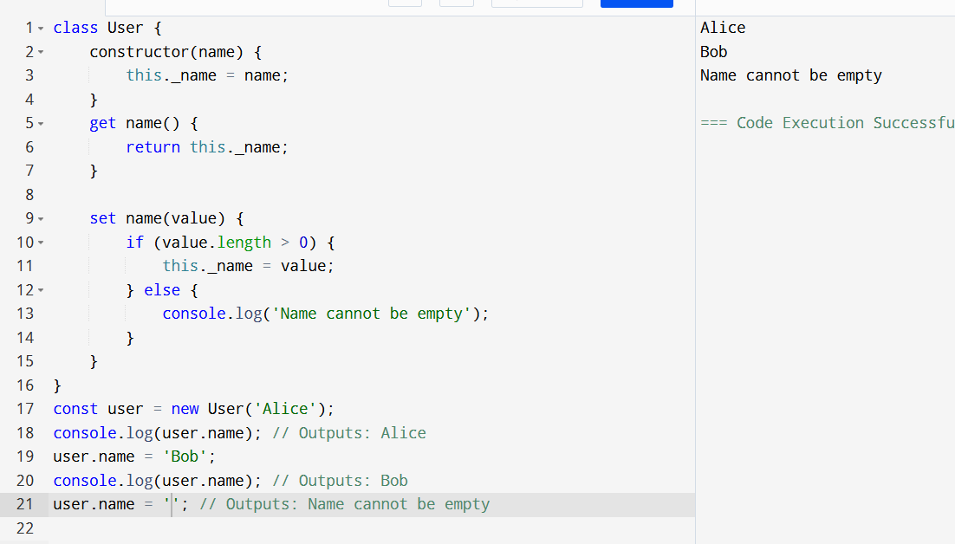

Difference 🡪

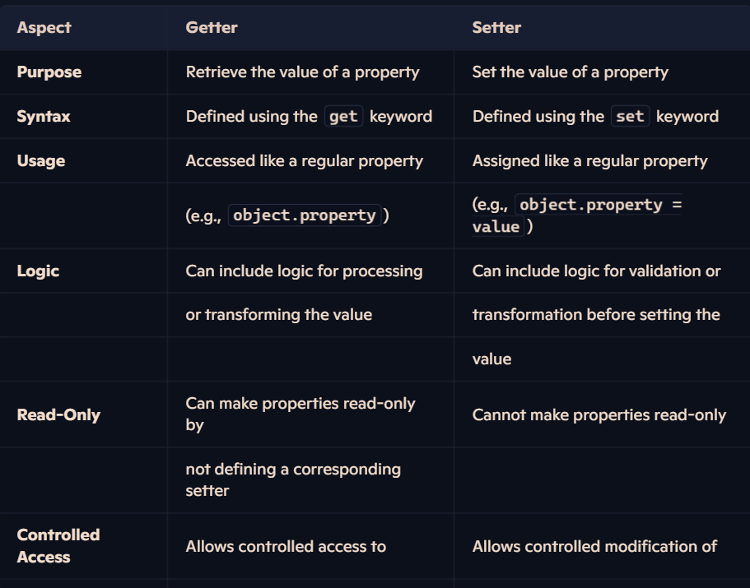

Only get use 🡪

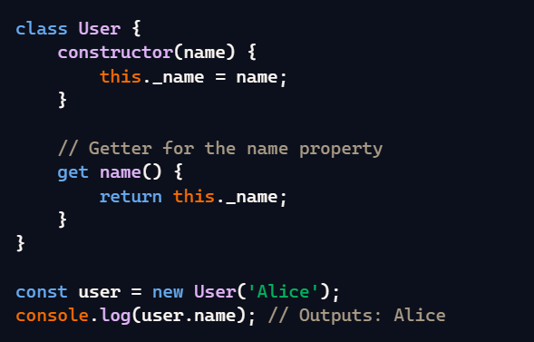

Only value Set :🡪

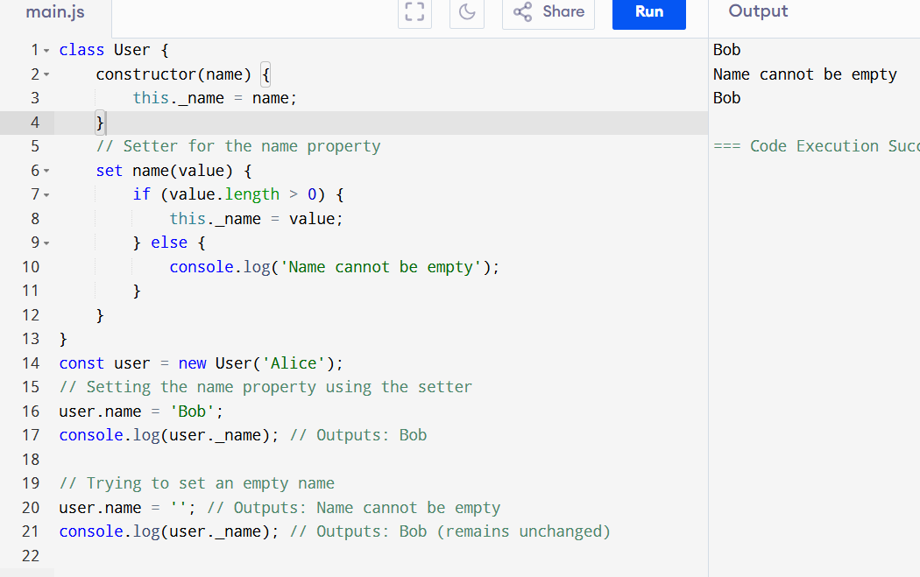

10.6 Static Methods  
10.7 Class Inheritance

**10.6 Static Methods**

**Theory**: Static methods are functions that are defined on the class itself rather than on instances of the class. They are called directly on the class and do not require an instance to be invoked. Static methods are often used for utility functions, such as creating or configuring objects.

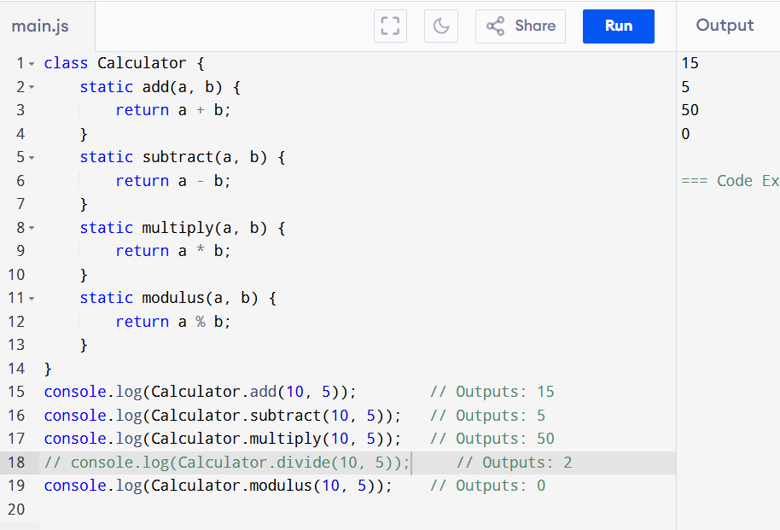

**10.7 Class Inheritance**

**Theory**: Class inheritance allows one class to inherit properties and methods from another class. This is achieved using the extends keyword. The subclass can also have its own additional properties and methods or override the parent class's methods.

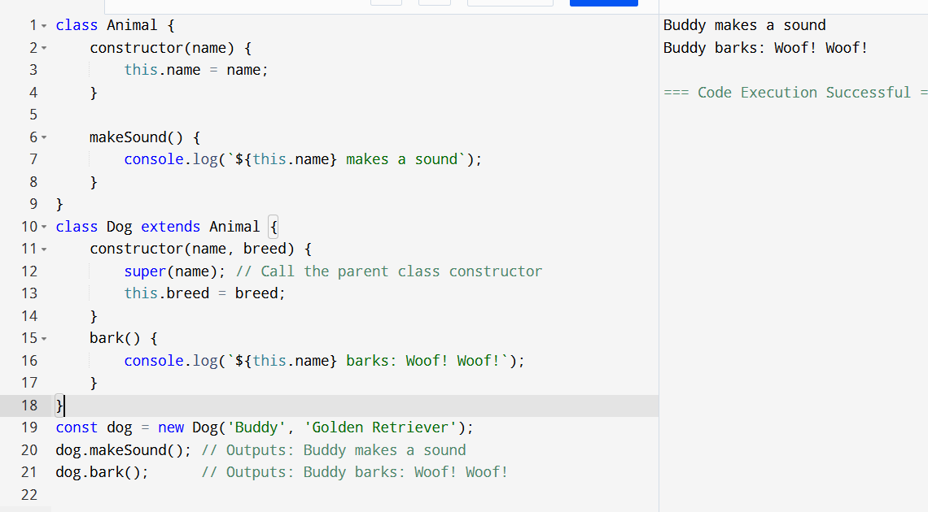

**10.9 Chaining of Methods**

**Theory**: Method chaining is a technique that allows you to call multiple methods on the same object consecutively in a single statement. Each method returns the object itself, allowing further methods to be called on it.

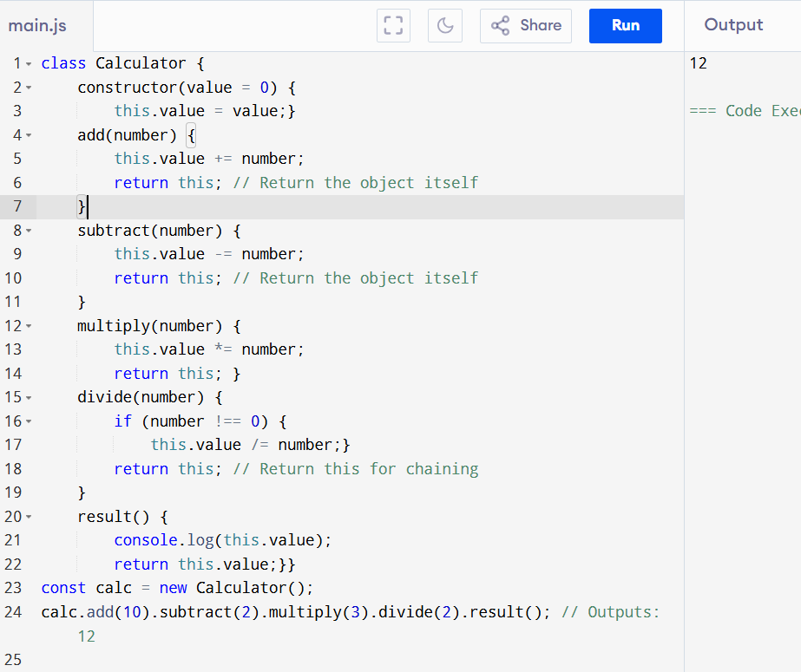

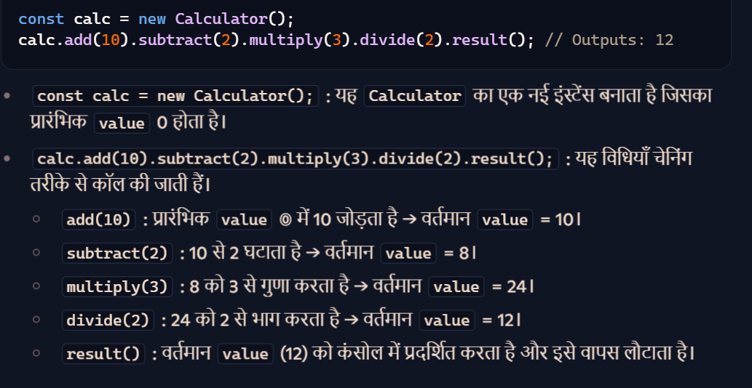

PROJECT 🡪

TODO List:

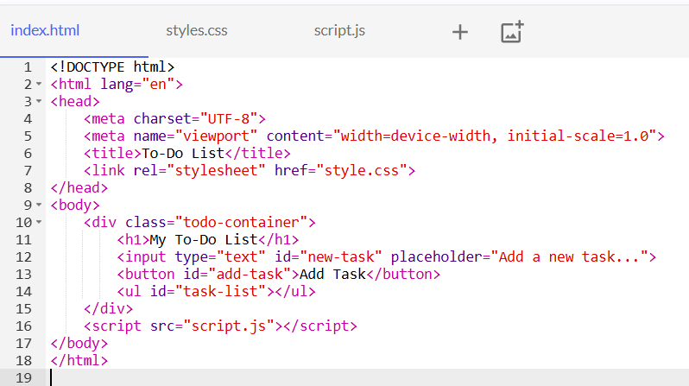

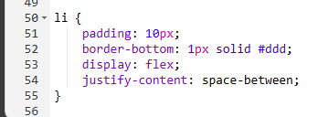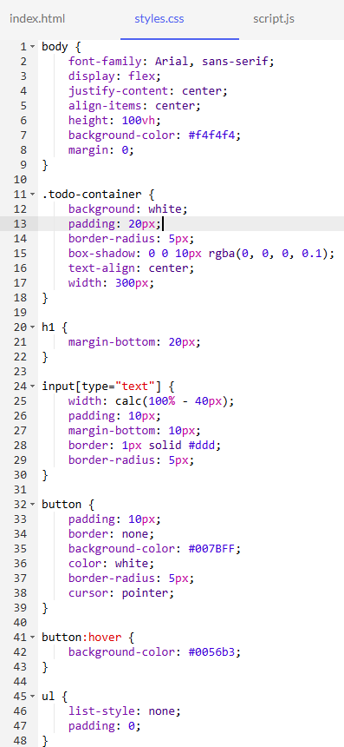

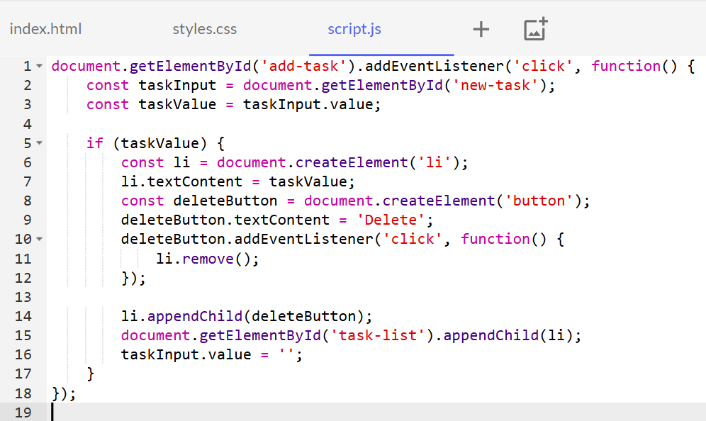

o/p ->

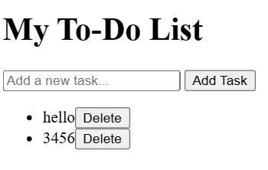

### 🡺 ✅ What is a Constructor?

A **constructor** is a special function used to **create and initialize an object** in object-oriented programming.

In **JavaScript**, the constructor is:

* Defined using the constructor() method inside a class.

### 🧠 Think of it like this:

A constructor is like the **blueprint’s builder** — it fills in the object’s details when you create it.

### 🔹 ****Constructor Definition (in simple Hindi + English):****

**Constructor** ek special function hota hai jo tab automatically chalta hai **jab object banate ho** kisi class ka.  
Iska kaam hota hai **object ke andar values set karna** (initialization).

With Constructor 🡺  
  
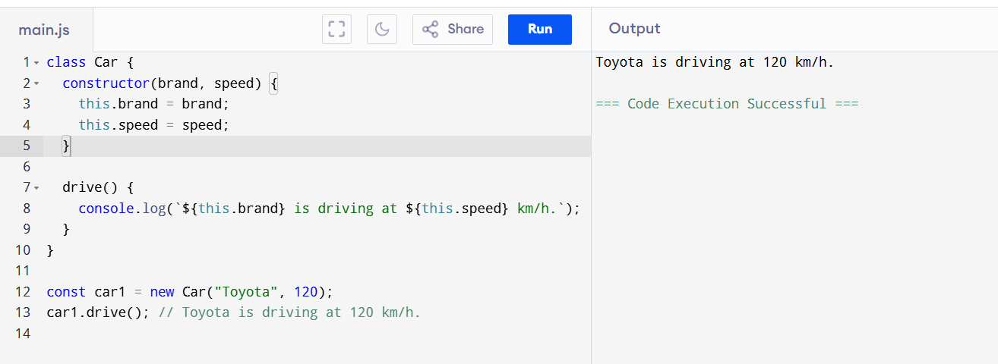

w/o 🡺  
  
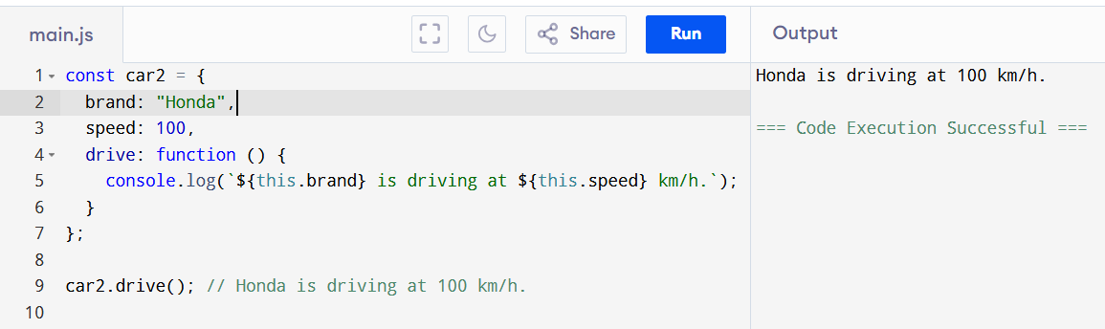

## 🡺 ✅ What is Inheritance?

**Inheritance** means one class (child) can use properties and methods of another class (parent).

Think of it like: **"Bachcha apne maa-baap ke features le sakta hai."**

## 🧬 **Types of Inheritance in JavaScript**

JavaScript supports inheritance mainly through **prototypes** and **classes (ES6)**.

Here are the main types:

### 1. ****Single Inheritance****

One child class inherits from one parent.

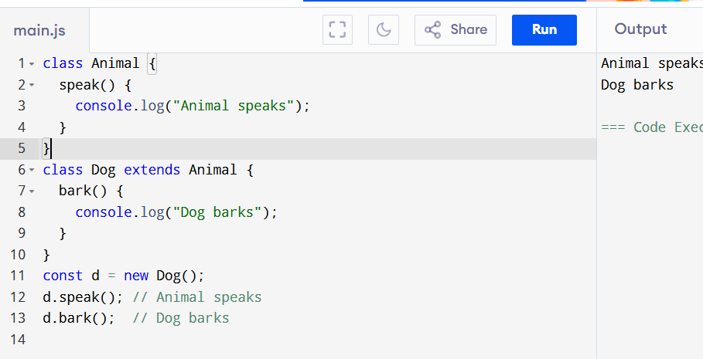

### 2. ****Multilevel Inheritance****

Child → Parent → Grandparent

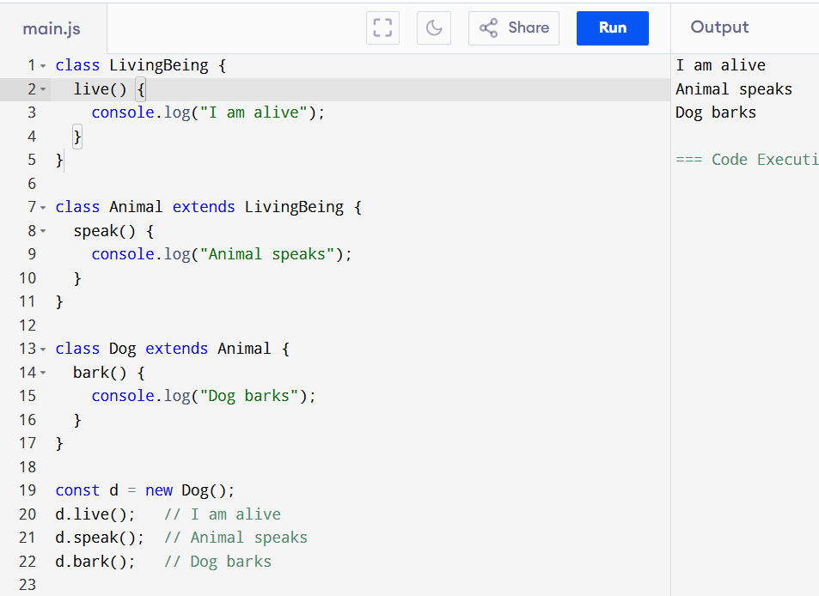

### 3. ****Hierarchical Inheritance****

One parent → multiple children

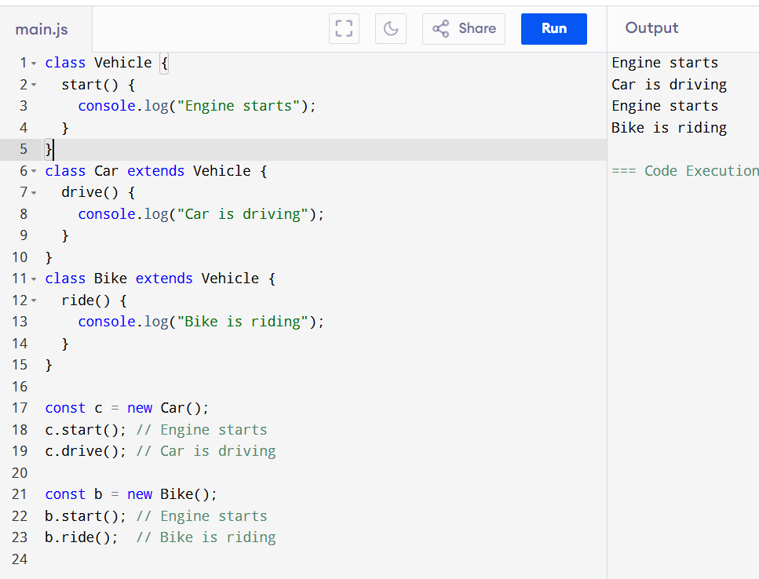

### ⚠️ 4. ****Multiple Inheritance (Not directly supported)****

JavaScript **does not support** true multiple inheritance (i.e., one class inheriting from multiple parents) but you can simulate it using **mixins**.

#### ✅ Mixin Example (Workaround for Multiple Inheritance):

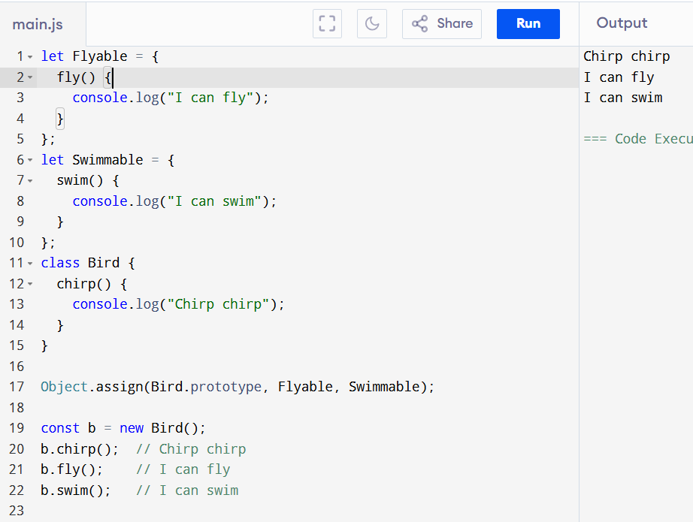

| **Inheritance Type** | **Supported?** | **Example Class Usage** |
| --- | --- | --- |
| Single | ✅ Yes | class B extends A |
| Multilevel | ✅ Yes | A → B → C |
| Hierarchical | ✅ Yes | One parent → many children |
| Multiple | ❌ (via mixins) | Object.assign() workaround |

## ✅ What is Encapsulation?

**Encapsulation** means **hiding internal details** of an object and only exposing **what’s necessary**.

Think of it like a **TV remote** — you don’t need to know what’s inside, just how to use it.

🡺  
Encapsulation is the process of **binding data and methods** together and **restricting direct access** to some of the object’s internal details.

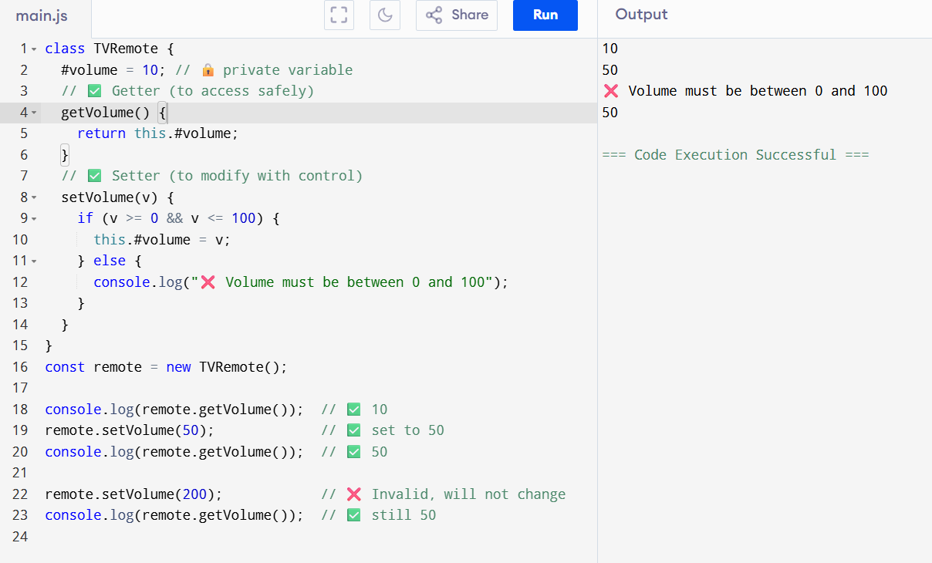

| **Symbol** | **Type** | **Compares** | **Converts Type?** | **Language** |
| --- | --- | --- | --- | --- |
| == | Loose | Value | ✅ Yes | JavaScript |
| === | Strict | Value + Type | ❌ No | JavaScript |
| .equals() | Method | Value | ❌ No | **Java only** |

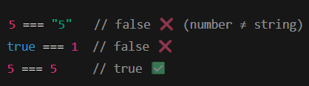

🡺constructor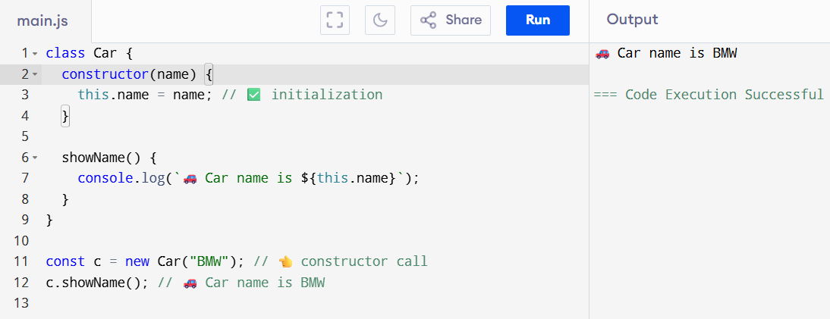

🡺  
Abstraction   
  
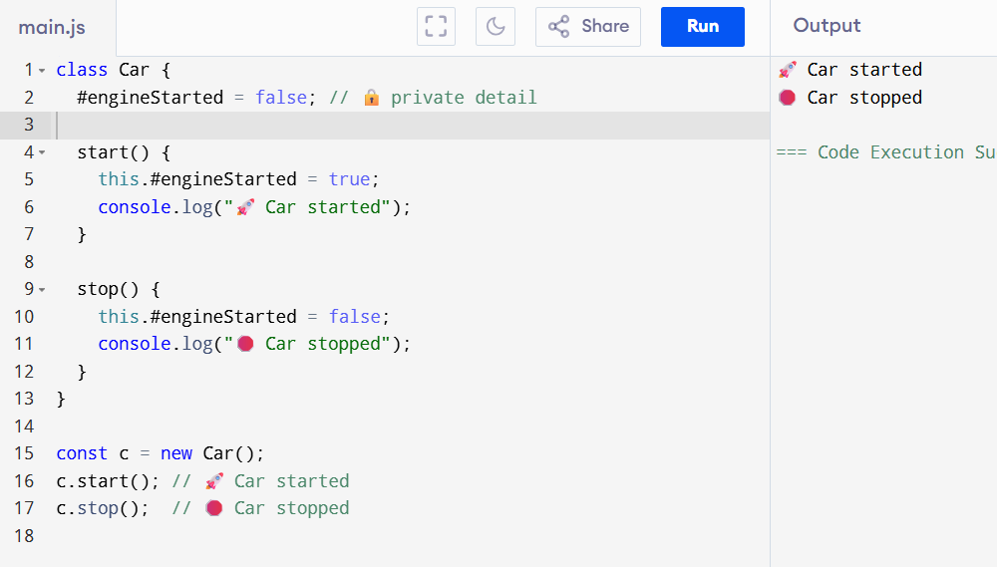

| **Feature** | **Constructor** | **Abstraction** |
| --- | --- | --- |
| Purpose | Object banate hi data set karna | Use karna asaan banana (andar ka logic hide) |
| Kab use hota hai? | new ClassName(...) ke time | Object banne ke baad |
| Focus | Initialization (setup) | Hiding complexity |
| Visible to User | Yes (constructor(...)) | No (andar ka logic nahi dikhata) |

## ✅ What is **Polymorphism**?

**Poly** = many  
**Morph** = form  
So, **Polymorphism** means:  
**"Ek hi cheez ka alag-alag form ya behavior."**

### 🔹 Real-life Example:

* **“draw()” function**:
  + Circle ke liye **draw a circle**
  + Square ke liye **draw a square**
  + Rectangle ke liye **draw a rectangle**

| **Type** | **Description** |
| --- | --- |
| 1. Method Overriding | Same method name, different classes |
| 2. Duck Typing | JS ka unique style — function call based on behavior |

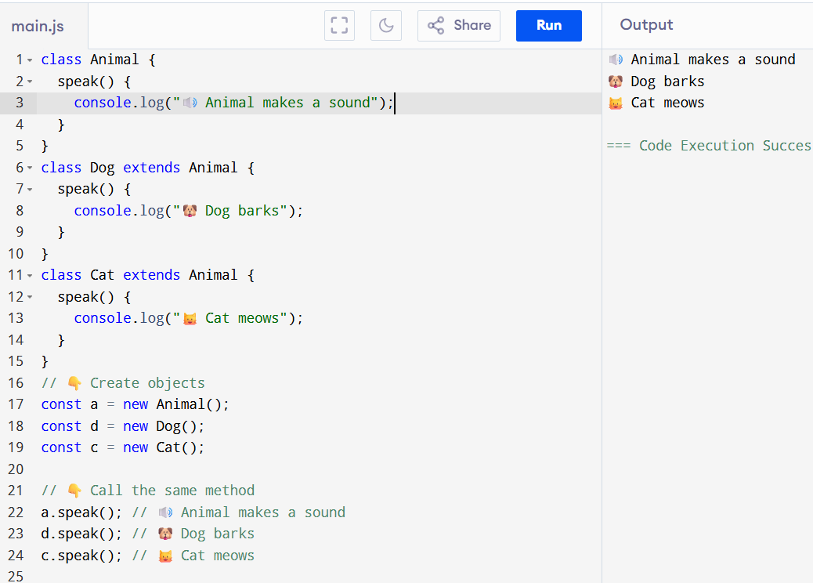

## 🔶 Duck Typing Simple Definition:

**"Agar koi object kisi method ko support karta hai, to hum use wo method call kar lete hain — bina ye jaane ki wo kis class ka hai."**

Iska naam hai:  
**"Agar wo duck ki tarah chalta hai, aur duck ki tarah awaaz karta hai, to wo duck hi hoga."**

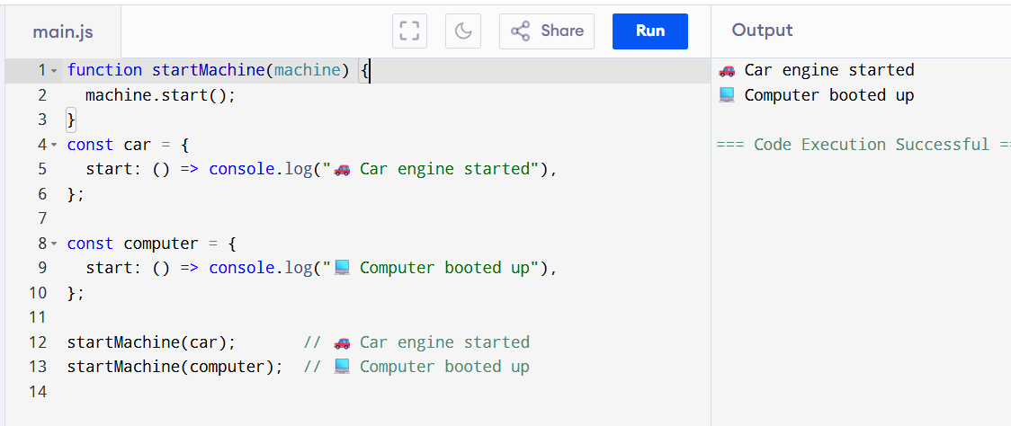

| **Concept** | **Status** | **Tera Progress** |
| --- | --- | --- |
| **Constructor** | ✅ | constructor() se object init kiya |
| **Encapsulation** | ✅ | private variable + getter/setter (like TV Remote) |
| **Abstraction** | ✅ | sirf zaroori method dikhaye, logic chhupaya |
| **Inheritance** | ✅ | extends keyword, base → derived |
| **Polymorphism** | ✅ | same method name, different behavior |
| **Duck Typing** | ✅ | JS special — method hona chahiye, class check nahi |